Creating an Animation Scene in PowerPoint

Directions: Follow all the steps below to create a kitchen animation presentation in PowerPoint.

- Copy and paste the PowerPoint titled kitchen from the public drive and paste it in your PowerPoint folder in your home drive. If you don’t have a PowerPoint folder in your home drive, create one.
- Open the PowerPoint titled kitchen.
- On slide one, type in an appropriate title such as The Kitchen in the first text box.
- Make sure you type in your name in the second text box.
- You can change the background color and font scheme later.
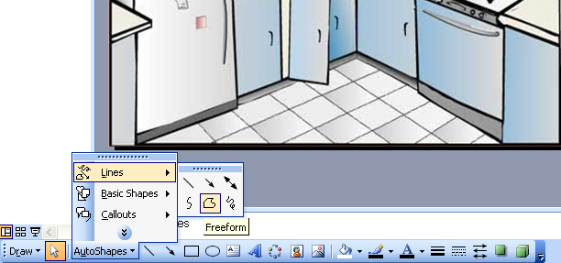
- Go to slide two and start drawing one object at a time. Most of the objects will require you to use the Freeform tool. To get to the Freeform tool, click on AutoShapes then scroll up to Lines and then select the Freeform option.
Tip: If the drawing tools aren’t showing, select View from the main menu and choose Toolbars | Drawing
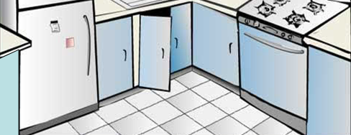
- Draw one object on the slide. You can change the color, but in this example, they will all be some basic color and the colors will be changed later. The arrow is pointing to the first drawing.
- Immediately insert a duplicate slide by choosing Insert | Duplicate Slide from the main menu.
- On slide three, you will create another object. You will continue to insert duplicate slides and draw an object at a time.
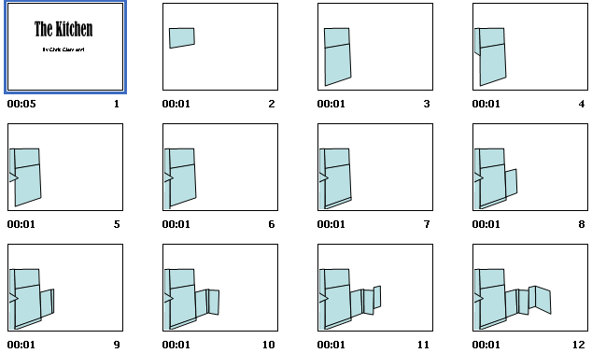
- You will also remove the original kitchen scene so that the presentation begins to look like the following example: Each new slide has a new object drawn.
- Once all the objects are drawn, you can start filling them in with colors or fill effects. For instance, you can save an image of mahogany or other wood patterns and make your cabinets filled with that image.
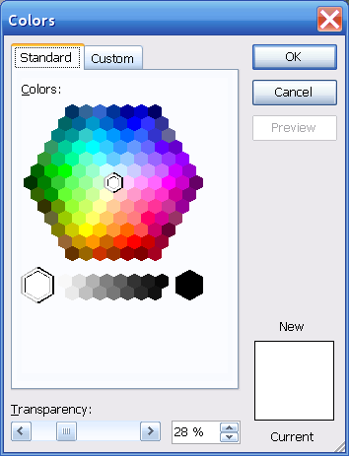
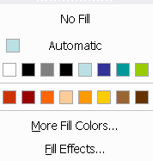
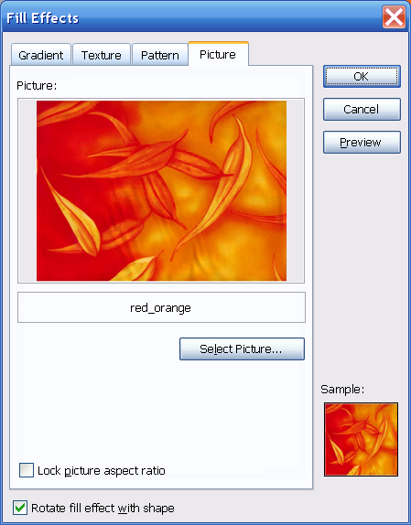
- To fill objects, click on the object and select the drop down menu of the paint bucket tool. You can either choose More Fill Colors or Fill Effects.
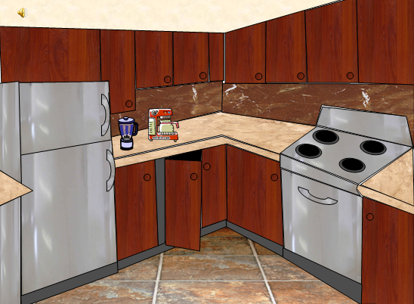
- The following image is an example of the final scene with an animated coffee pot. The blender was created using the tools in PowerPoint. The coffee pot was copied from an animated gif site.

Finalizing the Movie
- Click on the last slide and choose Insert | New Slide from the main menu.
- Choose Format | Slide Layout from the main menu.
- Click on the Title Only option of the Slide Layout window that should have popped up on the right hand section of the screen.
- Type in The End! in the text box. If you prefer using Word Art instead, you could click on Blank from the Slide Layout window and click on the Word Art tool.
- To make the presentation go really fast, select Slide Show | Slide Transition from the main menu.
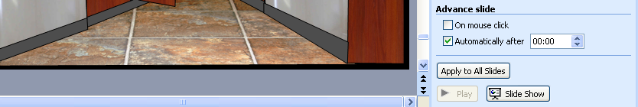
- Click on Automatically after to 00:00 under the Advance slide option.
- Make sure you click on Apply to All Slides.
- Once all slides are set to zero seconds, click on slide one or your title page and set the seconds to more than zero. Do the same for the last slide. In the classroom example, the slide that had the coffee pot brewing was set to three seconds. Make sure you DON’T click on Apply to All Slides or you will have to do step 18-21

