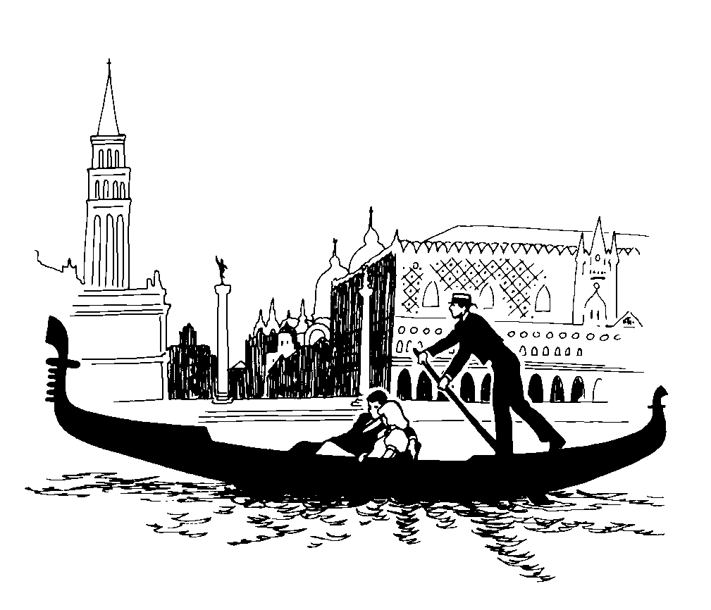
Rubric for creating the interactive activity in Microsoft Excel
Keep in mind that an automatic 10 points will be added for hiding the answers from the users before they test your interactive activity. Total possible points: 60 points

CATEGORY | 9-10 | 6-8 | 3-5 | 0-2
Accuracy of Content | All information in the hints category is accurate. | All but one fact in the information in the hints category is accurate. | At least two facts in the information of the hints category are accurate. | Several statements in the hints category are inaccurate.
Attractiveness | All images used to represent the clues are of good quality and of the same size. | All but one image used to represent the clues is of good quality and of the same size. | At least two images used to represent the clues are of poor quality and of the same size. | Several images used to represent the clues are of poor quality and of the same size.
Clues | The clues given distinguish the answer from other possible answers without immediately giving the answer away. | Most of the clues given distinguish the answer from other possible answers without immediately giving the answer away. | Some of the clues given distinguish the answer from other possible answers without immediately giving the answer away. | Few if any clues given distinguish the answer from other possible answers without immediately giving the answer away.
Spelling and Grammar | No spelling and grammar errors were made. | At least one spelling and grammar error was made. | Some spelling and grammar errors were made. | Several spelling and grammar errors were made.
Feedback | All feedback is appropriate and accurate. There are more than 5 different responses in the feedback section. Two or more feedbacks include the OR function. | All feedback is appropriate and accurate. There are less than 5 and more than two different responses in the feedback section. Less than two feedbacks include the OR function. | All feedback is appropriate and accurate. There are only two different responses in the feedback section. None of the feedbacks involve the OR function. | Most feedback is appropriate and accurate. There are only two different responses in the feedback section. None of the feedbacks involve the OR function.

