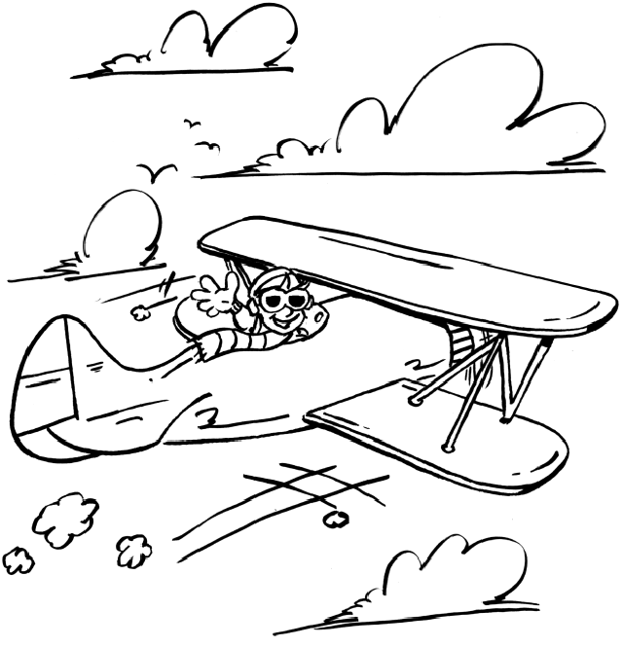
Cool Places for Kids to Travel

Directions: Choose at least 10 places to represent in your interactive activity in Microsoft Excel. You are welcome to use fun places that aren’t on the list. Use places that most students have never heard of.
- Jericho
- The Kremlin
- Kruger National Park
- Lake Baikal
- Lake Titicaca
- Leaning Tower of Pisa
- Machu Picchu
- Maelstrom
- Mammoth Cave
- Meenakshi Temple
- Mesa Verde
- Mauna Loa
- Monument Valley
- Mount Fuji
- Mount Rushmore
- Museo de las Momias
- The Nazca Lines
- Neuschwanstein Castle
- Newgrange
- Niagara Falls
- Pamukkale
- Petra
- Petrified Forest
- Phang Nga Bay
- Pitch Lake
- Pompeii
- The Pompidou Center
- Potala Palace
- The Ross Ice Shelf
- Rotorua
- Salar de Uyuni
- Sargasso Sea
- The Shipwreck Coast
- Singing Dunes
- The Stone Forest
- Stone Mountain
- Stonehenge
- The Sudd
- The Taj Mahal
- Terra Cotta Warriors
- Tower of Pisa
- The Tsingy Lands
- Tula
- The Vatican
- Versailles
- Victoria Falls
- Warriors of Xian
- Windsor Castle
- El Yunque

- Alcatraz
- Angel Falls
- Angkor Wat
- Arches National park
- The Badlands
- Barringer Meteor Crater
- Blue Holes of Andros
- The Blue Mosque
- Bora Bora
- Bran Castle/Dracula’s Castle
- Brooklyn Bridge
- Bryce Canyon
- Cappadocia
- Carlsbad Caverns
- Catacombs of Rome
- Cliffs of Moher
- Colosseum
- Crater Lake
- Crystal River
- The Dead Sea
- Death Valley
- Easter Island
- The Eiffel Tower
- Empire State Building
- Ephesus
- The Everglades
- Fez Medina
- Florissant Fossil Beds
- The Forbidden City
- Galapagos
- The Giant’s Causeway
- Golden Gate Bridge
- The Grand Canyon
- The Great Barrier Reef
- The Great Pyramid
- Great Wall of China
- Hearst’s Castle
- Hoover Dam
- Iguazu Falls
- HundertwasserHaus

