Formal Circle Checklist

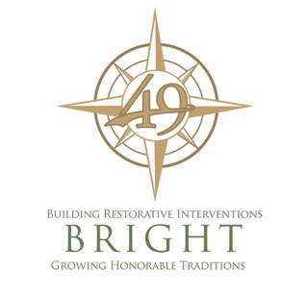
Formal Circle Checklist

General Inforation
Request made by:
Location:
Phone number/ email:
Number in circle:
Description:

CHECKLIST
Restorative Intervention Request form received
Request cleared by BRIGHT team (if applicable) LHolland@d49.org
Has this group experienced proactive circles?
Private location is secured
“Meeting in progress” sign
RP Cards and BRIGHT trifold info fliers
Your business cards (or Lea’s cards)
Pens
Tissues
Script of questions
Talking piece
Name tags for all participants
Second facilitator arranged as note taker (determine roles (lead vs note taker) prior to circle)
Who will be the leader present?
If applicable, food for “breaking bread”
Circle agreement form (3 copies; 2 as rough draft, 1 as final copy)
Simple snacks for “breaking bread”
Email participants with final copy
All parties have been spoken to about RP process and expectations

