**SAND CREEK**

**HIGH SCHOOL**

**AFJROTC**

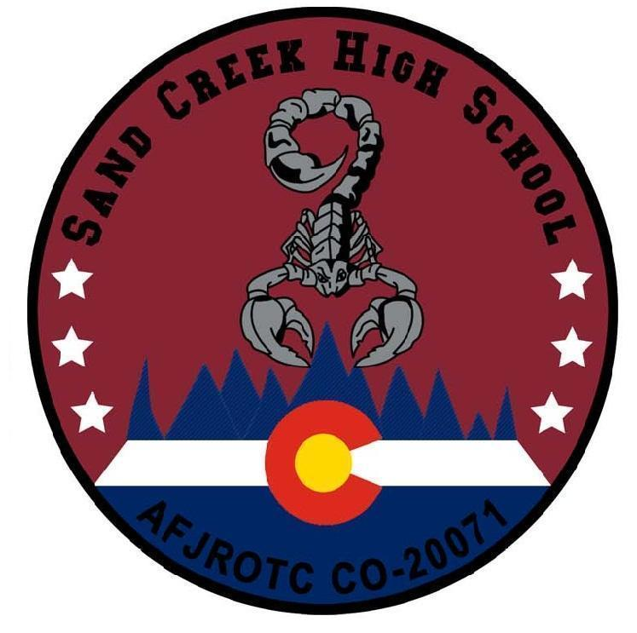

CADET GUIDE

2024-2025



**TABLE OF CONTENTS**

PAGE

Foreword 6

Section 1 Mission, Goals, Objectives, Enrollment, and Benefits 7

Mission, 7

Purpose 7

Vision 7

Core Values 7

Cadet Creed 8

Post Graduation Benefits 8

Section 2 Unit Operations 9

Organization 9

Corps Management 9

Eligibility 9

Transfers 9

Cadet Permanent Rank 9

Temporary Rank 9

Promotion Opportunities 10

Chain of Command 10

Section 3 Curriculum and Classroom Management 12

General 12

School Conduct 12

Classroom Entry 12

Classroom Exit 12

Classroom Rules 12

Academic Program 13

Curriculum Plan 13

Section 4 Customs and Courtesies 14

General 14

Military Courtesy 14

Saluting 14

Reporting In/Out of Instructor’s Office 14

Military/JROTC Protocol 14

Position of Honor 14

Classroom Expectations 14-15

Section 5 Special Programs and Activities 16

Safety and Supervision 16

Award of Ribbons and Badges 16

Curriculum in Action (CIA) 16

Cadet Color Guard 16

Cadet Drill Team 16

Kitty Hawk Honor Society (KHHS) Program 17

Community Service 17

Model Rocketry 17

Stellar Xplorers 17

Robotics 17

Unmanned Aircraft Systems (UAS) 17

JROTC Leadership & Academic Bowl (JLAB) 17

Awareness Presentation Team (APT) 17

Military Ball 17

Other 17

Section 6 Unit Organization and Position Rotation 18

Chain of Command and Cadet Authority 18

Cadet Officers 18

Cadet NCOs 18

Cadet Position Rotation 18-19

Cadet Position Selection Criteria 19

Organization Chart/Chain of Command 69

Section 7 Uniform Standards 20

Uniform Issues 20

Uniform Days 20

Physical Training Uniform 20

Typical Monthly Uniform Rotation 20

Wear and maintenance 20-21

Cadet Appearance and Groom Guidelines 22

Hair Male and Female 22

Jewelry 22-23

Tattoos 23

Body Piercing 23

Back Packs 23

Headphones 23

Specific Female Cadet Grooming Guidelines 24

Hair Female 24

Fingernails 24

Earrings 25

Cosmetics 26

Body Piercing/ornamentation 26

Authorized Female Hair Examples 27-28

Unauthorized Female Hair Examples 28

Additional Female Hair Examples 29

Hair Male 30

Mustache 31

Beards 31

Sideburns 31

Fingernails Male 31

Male hair style examples 31

Cadet Uniform Wear Policy for School Events 32

Cadet Uniform Wear Guidance for fundraising 32

Attachment 7-1 AFJROTC Badges and Insignia 33-33

Attachment 7-2 AFJROTC Rank and Insignia 34

Attachment 7-3 Cadet Male Headgear 35

Attachment 7-4 Cadet Female Headgear 36

Attachment 7-5 Cadet Beret Headgear 37

Attachment 7-6a Cadet ABU Male and Female 38

Attachment 7-6b Cadet OCP Male and Female 39

Attachment 7-7 Cadet ABU and OCP Headgear 40

Attachment 7-8 Cadet Light Weight Blue Jacket 41

Attachment 7-9 Cadet Male Service Dress 42

Attachment 7-10 Cadet Female Service Dress 43

Attachment 7-11 Cadet Male Blue Shirt 44

Attachment 7-12 Cadet Female Blue Shirt 45

Attachment 7-13 Flight Suit 46

Attachment 7-14 Semi-Formal Dress Uniform 47

Attachment 7-15 Sample Exhibition Uniform 48

Attachment 7-15 Cont- Sample Exhibition Uniform 49

Attachment 7-16 Sample Uniform Pictures 50

Attachment 7-16 Cont- sample uniform Pictures 51

Attachment 7-16 Cont- Sample PT Uniform Pictures 53

Check Uniform 54

Section 8 Awards 55

Awards and Decorations 54-55

Awards by National Organizations 55-59

AFJROTC Awards and Ribbons 59

How to earn awards 59

Wear of Ribbons 59

Wear of Medals 59

CO-20071 Uniform Cords 60

Section 9 Discipline System 61

Hazing 61

Cadet Evaluation Board 61

Disenrollment 62

Section 10 AFJROTC Letter Program 63

Criteria 63

Purpose 63

Application 64

Section 11 Health and Wellness Program 65

Purpose 65

Cadet Fitness Test 65

Section 12 Community Service 66

Importance 66

Requirements 66

Community Service Events

**CADET GUIDE ATTACHMENTS**

Attachment 1 Chain of Command (National and Unit) 67-68

Attachment 2 CO-20071 Unit Manning Document (UMD) 69

Attachment 3 CO-20071 Cadet Job Descriptions 70-73

Attachment 4 Sand Creek High School Letter Application 74

Attachment 5 Phonetic Alphabet 75 Attachment 9 How to tie a Tie 76-77

Attachment 10 Ribbon Chart 78

**FOREWORD**

This “Cadet Guide” was developed to familiarize you with Sand Creek High School Air Force Junior Reserve Officer Training Corps (AFJROTC) requirements and expectations. It will enable you to maintain the high standards required to become an effective member of the cadet corps.

Our ultimate goal is to provide each cadet with the necessary tools to become the best citizen possible. This objective can only be achieved through the daily efforts of every cadet enrolled in AFJROTC at Sand Creek High School. You can do your part to improve our unit and cadet corps by learning the contents of this guide, adhering to the rules and procedures we’ve established, and putting forth your best effort every day.

Your achievements and accomplishments in AFJROTC as well as your development as a leader and responsible citizen will depend on you and the spirit in which you abide by the provisions in this guide.

Keep a positive outlook – attitude is everything!

RYAN D. PONTIUS, Lt Col, USAF (Ret)

Senior Aerospace Science Instructor

BENJAMIN D. BROWN, CMSgt, USAF (Ret)

Aerospace Science Instructor

**Section 1: MISSION, GOALS AND OBJECTIVES**

**Mission:** Develop citizens of character

**Purpose:** Instill in students the value of citizenship, service to the United States, personal responsibility, Character, and a sense of accomplishment.

**Vision Statement:** Air Force Junior ROTC will provide a quality citizenship, character, and leadership development program, while fostering enduring partnerships and relationships with high schools, educational institutions, and communities that help meet our citizen development mission.

The AFJROTC program fully supports the Sand Creek High School mission which is “to *empower students to be the best versions of themselves wherever they may go”.*

**Air Force Mission**

The mission of the United States Air Force is to fly, fight and win… airpower anytime, anywhere.

**Core Values**

The United States Air Force core values provide a strong foundation for our AFJROTC organization. The Sand Creek High School beliefs are also woven throughout the program.

**Integrity first**

The willingness to do the right thing even when no one is looking.

**Service before self**

Professional duties take precedence over personal desires.

**Excellence in all we do**

A sustained passion for continuous improvement.

**Cadet Creed**

I am an Air Force Junior ROTC Cadet.

I am connected and faithful to every Corps of Cadets who serve their community and nation with *Patriotism*.

I earn respect when I uphold the Core Values of *Integrity First*, *Service Before Self*, and *Excellence in All We Do*.

I will always conduct myself to bring credit to my family, school, Corps of Cadets, community, and to myself.

My character defines me.  I will not lie, cheat, or steal.  I am accountable for my actions and deeds.

I will hold others accountable for their actions as well.

I will honor those I serve with, those who have gone before me, and those who will come after me.

I am a Patriot, a Leader, and a Wingman devoted to those I follow, serve, and lead.

I am an Air Force Junior ROTC Cadet.

**Enrollment**

All AFJROTC students must be enrolled voluntarily and participate in the full program to include taking AFJROTC academic courses, participating in the cadet corps, and wearing the prescribed uniform.

**Disenrollment**

Cadets not meeting standards will be counseled by cadet leaders and instructors. Cadets who are unwilling to make the needed corrections will be disenrolled from the program. Disenrollment is the last resort and will be preceded by documentation and counseling. However, if these efforts are unsuccessful the SASI will remove the cadet from the program. Cadets may be disenrolled from Air Force JROTC based on any highly inappropriate conduct in or out of school. Disenrollment may occur at any time during the semester.

**Reserve Cadet**

A reserve cadet is a student who is not participating in a AFJROTC course during the current term, but desires to participate in Air Force JROTC activities. A student must have been a cadet for at least 1 academic year and there must be extenuating circumstances that prevent the student from enrolling in an Air Force JROTC class. Final approval for reserve status rest with the SASI. Reserve cadets may be issued a uniform and be allowed to participate in the program. Time in reserve status does not count towards the Certificate of Completion.

**Post-Graduation Benefits**

Students who successfully complete the AFJROTC academic program as prescribed by public law and Air Force instruction will be awarded a Certificate of Completion. An Air Force form 1256, *Certificate of Training,* will be awarded for completion of 2 academic program years. An Air Force form 310, *AFJROTC Certificate of Completion will* be awarded upon successful completion of 3 or 4 academic program years.

In accordance with DOD policy, JROTC cadets may be eligible for enlistment at a higher grade. Additionally, students completing 2 years of JROTC may be entitled to credit in the Senior ROTC program. Honor graduates of high performing JROTC programs are also eligible to compete for a select number of Service Academy Nominations.

**Section 2 UNIT OPERATIONS**

**Organization**

The AFJROTC unit at Sand Creek High School has been designated “Colorado 20071” (CO-20071).  The cadet corps is organized as a group composed of two squadrons with two to three flights in each squadron. Each class period is designated a flight. Period 1 is Alpha Flight with periods 2-8 designated Bravo-Hotel. The phonetic alphabet is listed in Attachment 17.  An organizational chart is depicted at Attachment 1.

**Corps Management**

Leadership and management of the corps is the responsibility of the cadets.  The Senior Aerospace Science Instructor (SASI) and the Aerospace Science Instructor (ASI) are responsible for the overall function of the unit, teaching in accordance with established curriculum, and providing the framework and guidance under which the corps operates.  The cadets are assigned positions of responsibility in a variety of areas and presented with leadership challenges designed to give them valuable management and decision-making opportunities.

**Eligibility**

Our program is offered to all Sand Creek High School students (9-12 grade). A student may join at any grade level but must start with the 1st Year curriculum. District 49 charter school and home-schooled students may participate in AFJROTC at Sand Creek but must provide their own transportation and work out any scheduling issues with their school. In addition, a cross-town agreement would need to be established between Sand Creek High School and the D49 charter school.

**Transfers**

Transfer students and students coming from other JROTC programs (Army, Navy, Marine, etc.) may join JROTC but must realize there are some differences among the different service programs. Transfer students will usually start with permanent rank (see below)

**Cadet Permanent Rank:**  Cadets have a permanent rank determined by the years of AFJROTC successfully completed. Permanent ranks are as follows:

First Year                           Cadet Airman

Second Year                       Cadet Airman First Class

Third Year                          Cadet Senior Airman

Fourth Year                        Cadet Staff Sergeant

Cadets of CO-20071 are expected to be leaders in our classroom, school, and community and will pursue opportunities for advancement in the program.

**Temporary rank** is awarded based on a specific assigned position.  Promotion to temporary ranks is based on factors such as performance, self- discipline, classroom decorum, proper uniform wear and desire to assume responsibility.  Temporary Ranks:

Flight Commander First Year                       Cadet Staff Sergeant

Flight Commander Second Year                     Cadet Technical Sergeant

Flight Commander Third- and Fourth-Year      Cadet Master Sergeant                               
Flight Sergeant First Year Cadet Senior Airman

Flight Sergeant Second Year Cadet Staff Sergeant

Flight Sergeant Third Year Cadet Technical Sergeant

**Promotion Opportunities for AS4 Cadets**

If a cadet has an AS4 position in the Corps, then a promotion opportunity will be available at the beginning of the second semester each academic year. The AS4 cadet must write a self-nomination letter to the SASI/ASI to take advantage of this opportunity. The letter must detail why the AS4 cadet should be promoted. The promotion decision will be made by the SASI and ASI.

**Promotion Opportunities for AS1, AS2 and AS3 Cadets**

AS1, AS2 and AS3 cadets will have a promotion opportunity available at the beginning of the second semester each academic year. The two tables below outline the requirements for an AS1, AS2 and AS3 to be promoted. After the requirements in the tables are met then the promotion decision will be made by the SASI and ASI. Note that this process applies to AS1, AS2, and AS3 permanent ranks.

| Year | JROTC Grade | Cumulative Weighted GPA | Community Service | Promotion Test | 30-Step Drill Sequence |
| --- | --- | --- | --- | --- | --- |
| AS1 | B+ or Higher (Fall of the current Academic Year) | Minimum of 3.0 | At least 6 hours of community service during the current Academic Year | Take the Promotion Test and score no lower than 80% | Be able to march the 30-Step Drill Sequence |
| AS2 |
| AS3 | Be able to command the 30-Step Drill Sequence |

|  |  |  |  |  |  |
| --- | --- | --- | --- | --- | --- |
| Year | American Flag ribbon | Color Guard Certification | Extracurriculars | Physical Fitness | Letter of Recommendation |
| AS1 | Completed 5 flag details per academic year | Be Color Guard certified | Must show participation in corps;  Must show participation in AFJROTC Extracurricular activities | Minimum 30% PFT score or 10% increase from previous PFT | Not required |
| AS2 | Minimum 30% PFT score or 10% increase from previous PFT |
| AS3 | Minimum 50% PFT score or 15% increase from previous PFT | Letter of Recommendation from an AS4 |

**Chain of Command**

The chain of command starts at the lowest level and works its way up.  Issues and problems should be resolved at the lowest level possible. Cadet officers and noncommissioned officers (NCOs) are vital to an effective and efficient corps. They provide the leadership necessary in any successful organization. Every cadet will be afforded the opportunity to hold an NCO or officer position at some time.

**Cadet Officers**

Have shown their potential and serve as role models for other cadets. Cadets must exercise both leadership and followership skills and must remember that authority and responsibilities are limited to corps activities.

**Cadet NCO**

Assist the cadet officers and must also serve as role models for the rest of the cadet corps. Must address rule violations as they occur. Must remember that authority and responsibilities are limited to corps activities. Are responsible for the appearance and discipline of their cadets.

**SECTION 3 CURRICULUM AND CLASSROOM MANAGEMENT**

**General**

Cadets are expected to display proper self-discipline at all times in the classroom (and throughout the school and community). Compliance with the customs and courtesies of the AFJROTC program are not optional. Cadet behavior, in and out of uniform, reflects upon the individual and our program. In uniform, the cadet is representing the United States Air Force.

**School Conduct**

The faculty and staff at Sand Creek High School form opinions about the AFJROTC program based on the actions of cadets they observe. The GREAT reputation our unit has with the school is based largely due to the outstanding conduct of our cadets.

**Classroom Entry**

All cadets will enter the classroom , place their personal items in a proper place and stand directly behind their desk in the “AT EASE” position.

At class start, the flight commander will bring the flight to “ATTENTION”, and then “PARADE REST”. They will then take roll. As each cadet’s name is called, the cadet will come to “ATTENTION” and respond with “HERE SIR/MA’AM”. The cadet will then return to “PARADE REST”.

After the completion of the roll call, the flight commander will bring the flight back to “ATTENTION” position the flight to face the flag, and lead the class in the Pledge of Allegiance.

When the Pledge has been completed, the flight commander will instruct the flight to “FALL OUT”. At this time the cadets will take their seats. The Flight Commander will then report the attendance to the instructor and take their seat.

Any cadet arriving late for class (after the tardy bell) will report to the instructor and explain why they are late. Unexcused tardies should be very rare. In accordance with the Sand Creek attendance/tardy policy, students reporting more than 15 minutes late for class will be marked absent for the class.

**Classroom Exit**

At the end of the class period, the flight commander will direct the class to prepare for exit by returning books and cleaning up their areas. Cadets will not line up at the door.

At the end of the period, the flight commander will bring the flight to “ATTENTION” and dismiss them.

**Classroom rules**

At all times (In AFJROTC Class and ALL other classes), Cadets of CO-20071 will be prepared, courteous, responsible, and respectful. Hats, sun glasses, gum, and headphones are not allowed in AFJROTC. Vulgar and obscene language is not compatible with being a young person of character. Cadets of CO-20071 are expected to be leaders and should make attempts to improve the overall climate and culture of Sand Creek High School.

**Academic Program**

Sand Creek High offers a four-year AFJROTC curriculum. The curriculum includes Aerospace Science (AS), Leadership Education (LE), and Wellness/Physical Training (PT) components. AS, LE, and PT are blended within each course. (AS 40%, LE 40%, and PT 20%). All students will be granted academic credit toward graduation requirements for successful completion of AFJROTC courses.

**Aerospace Science**

AS acquaints students with the elements of aerospace and the aerospace environment. It introduces them to the principles of space flight, the history of aviation, development of air power, contemporary aviation, rocketry, propulsion the aerospace industry, and the study of some cultures across the world.

**Leadership Education (LE)**

LE is the portion of the AFJROTC curriculum that develops leadership skills and acquaints students with the practical application of life skills. The LE curriculum emphasizes discipline, responsibility, leadership, followership, citizenship, customs and courtesies, cadet corps activities, study habits, time management, communication skills, and drill and ceremonies.

**Cadet Wellness and Physical Training (PT)**

The purpose of the PT/Wellness Program is to motivate cadets to lead healthy, active lifestyles. PT/Wellness provides leadership opportunities, builds esprit de corps, and increases cadet confidence. Students are required to take the JROTC fitness test at the beginning and at the end of the academic year.

**Curriculum Plan**

The curriculum plan ensures a cadet will not take the same course, with the same material being taught, more than once. Cadets are not allowed to take the same course twice if successfully completed.

|  |  |  |  |  |
| --- | --- | --- | --- | --- |
| **CADET YEAR** | **2022/2023** | **2023/2024** | **2024/2025** | **2025/2026** |
| **1** | AS100/LE100 | AS100/LE100 | AS100/LE100 | AS100/LE100 |
| **2** | AS200/LE200 | AS200/LE200 | AS200/LE200 | AS200/LE200 |
| **3** | AS300/LE300 | AS300/LE300 | AS300/LE300 | AS300/LE300 |
| **4** | AS400/LE400 | AS400/LE400 | AS400/LE400 | AS400/LE400 |

**SECTION 4 CUSTOMS AND COURTESIES**

**General**

JROTC cadets will practice many customs that may be new to them. Your participation in these customs will ensure you have a rewarding experience in the JROTC program. Military customs and courtesies go beyond basic politeness. They play an important role in building morale, esprit de corps, and discipline.  Customs and courtesies ensure proper respect for the chain of command and build the foundation for the self-discipline that is important and necessary in times of crisis.  The following customs and courtesies are specific examples that are unique to the military.

**Military Courtesy**

The practice of saying “YES SIR” or “NO SIR”, “YES MA’AM” or “NO MA’AM”, is a common courtesy and a time-honored military tradition.  Cadets are expected to address instructors, teachers, and administrators in this manner. **RESPONDING WITH A “YEAH” IS NOT PERMITTED.** You may find this difficult at first, but it will soon become second nature.  This is a good habit that will bring you many benefits such as mutual respect.

**Saluting:**The salute is a traditional greeting between military personnel.  It is a way of saying hello while showing respect.  Cadets **must** salute all commissioned officers and cadet officers while outside, in competition, or in drill.

**MILITARY/JROTC PROTOCOL**

**Addressing Instructors**

SASI and ASI will always be addressed as Sir/Ma’am or by using rank and last name (e.g. Colonel Smith, Chief Jones, Sergeant White) or simply rank (e.g. Colonel, Chief, or Sergeant).

**Addressing Cadets**

Cadets will address each other in class and while in uniform as follows:

NCOs- If superior is a cadet NCO:  Cadet/rank or cadet/rank and last name.

Officers If superior is a cadet officer:  Cadet/rank or cadet/rank and name or “ Sir/Ma’am”.

If cadet is subordinate:  Cadet/rank or cadet/last name or cadet/rank and last name If cadet is of equal rank:  First name or cadet/rank or cadet/rank and last name.

**Position of Honor:**According to military customs and courtesies, the position of honor is always to the right.  When walking with an officer or cadet of a higher rank, the cadet will place himself/herself to the left of the senior.

**Classroom Expectations**

**Be Prepared**

* Get a good night’s sleep on nights before school
* Be on time for class; conduct restroom breaks before class
* Wear the uniform on the prescribed day
* Check whiteboards for assignments and notices

**Be Courteous**

* Be considerate of others and treat them with dignity and respect
* Address instructors by proper title (“Colonel or Chief)
* Be a good listener and request permission to speak by raising your hand
* Remain in your seat during class and asked permission to get up

**Be Respectful**

* Sit up straight and engage in the lesson
* Remove hats and sunglasses in class
* Do not use vulgar or obscene language
* Do not engage in horseplay or any disruptive behavior

**Do**

* Treat all other cadets, students and faculty with dignity and respect at all times
* Be positive – attitude is everything
* Be a good leader and a follower
* Request permission to speak/answer a question by raising your hand

**Hall Passes**

Cadets should use restrooms between classes to avoid disruptions during class time. If you need to go out during class you will need a pass from the instructor.

**SECTION 5 SPECIAL PROGRAMS AND ACTIVITIES**

There are several voluntary cadet extracurricular activities which supplement aerospace and leadership experiences. Additionally, these activities bring cadets with common interest together and build esprit de corps, lasting friendships, and enhance your overall experience in AFJROTC.

**Safety and Instructor Supervision**

When conducting any AFJROTC activity inside or outside of normal school hours, on or off school property, the program must comply with (and document when applicable) all school district safety, risk management, and supervision rules and policies. Cadets must be under direct instructor supervision during all AFJROTC activities.

**Award of Ribbons and Badges for Participation**

Participation in Special Programs and Activities by cadets is acknowledged with various special ribbons and badges

**Curriculum In Action (CIA)**

CIA is a term used to describe school-sponsored activities (field trips) that directly support or serve as an extension of the AFJROTC curriculum. They are sponsored and approved using the same procedures as any other class/organization at Sand Creek High. Maximum participation is highly encouraged.

**Visits to Air Force Installations**

Groups of AFJROTC cadets, under the supervision and control of an AFJROTC instructor, are authorized to take part in visits to Air Force installations to enhance the AFJROTC program. Visits serve as motivational activities for cadets and provide practical experiences complementing theoretical knowledge supplied in the AFJROTC curriculum

**Cadet Color Guard**

All cadets will be trained to do color guard. The color guard presents and posts the United States flag and the Colorado flag at school and non-school affiliated events outside of school. This highly visible activity provides an opportunity for cadets to learn respect and properly present national and state flags.

**Physical Training Activities (PT)**

AFJROTC instructors will ensure any program implementation is done with cadet safety as the primary consideration. PT is conducted every other week. Cadets are expected to dress-out in the issued PT attire and fully participate in PT activities. All cadets will be administered the Cadet Fitness Assessment at the beginning and end of the school year.

**Cadet Drill Team**

This team performs in local and area wide drill competitions and demonstrations. Participation requires and extra commitment from cadets since they spend many hours learning the manual of arms, perfecting teamwork, practicing movements, developing exhibition movements, and taking care of their uniform.

**Kitty Hawk Honor Society (KHHS) Program**

The Kitty Hawk Honor Society (KHHS) program is the official National Honor Society of AFJROTC and SFJROTC

**Community Service**

Community service is an important part of being in JROTC. All students are expected to participate in this rewarding and fun part of JROTC. There will be several service opportunities schedule throughout the school year. Cadets should plan on participating in approximately 12 hours of community service each year.

**Model Rocketry**

Model rocketry is the designing, building, and flying of rockets that are made of paper, plastic, balsa wood, or any other light weight material. The model rocketry program provides an introduction to concepts of aerospace engineering and design and the basic concepts of flight and space. It can motivate students to attain a greater knowledge of aerospace studies and arouse interest in aerospace careers.

**Stellar Xplorers**

Stellar Xplorers is a program to inspire and attract high school students to pursue science, technology, engineering and mathematics (STEM) education and careers. The program provides a hands-on, space design challenge involving all aspects of space systems development and operation with a spacecraft and payload focus.

**Robotics**

Robotics involves the design, construction, operations, and use of robots in a sports-like competition. During this process cadets will learn key STEM principles and robotics concepts.

**Unmanned Aircraft Systems (UAS)**

Unmanned Aircraft Systems involves the training and operations of Unmanned Aircraft Systems. During this process cadets will learn key STEM principles and concepts.

**JROTC Leadership & Academic Bowl (JLAB)**

JLAB is a nationally recognized academic competition created exclusively for JROTC students. By participating, cadets learn the values of citizenship, leadership, academic competition, and college opportunity.

**Awareness Presentation Team (APT)**

APT is an academic endeavor designed to provide positive role models for elementary and middle school students.

**Military Ball**

One of the highlight events of the year is the Military Ball. Cadets look forward to and thoroughly enjoy this event. Dress is Service dress or civilian equivalent. It is a sit down dinner followed by a dance.

**Other**

Veterans Day Parade, Field Day/BBQ, movies nights, game nights, ice cream socials

**SECTION 6 UNIT ORGANIZATION AND POSITION ROTATION**

**Chain of Command and Cadet Authority**

The chain of command starts at the lowest level and works its way up. If possible, cadets should first try to resolve issues and problems at the lowest possible level of leadership.

Dedicated Cadet Officers and NCOs are the key to an effective and efficient corps. They provide the leadership necessary in any successful organization. Cadets in management positions will ensure that all subordinates are given written job descriptions that inform of their exact duties.

Cadets have limited authority over junior ranking cadets within command relationships and over all cadets under their supervision during functional relationships/activities. Cadet managers are authorized to respectfully give direction to cadets who are junior in rank.

**All cadets are responsible to politely advise** other cadets if they are out of uniform or displaying unacceptable conduct. If the conduct is not corrected, the discrepancy should be reported up the chain of command. All cadets are obligated to be respectful of other cadets, regardless of rank or position. We take care of our own!

**Cadet Officers**

* Have normally shown their potential as cadet NCOs
* Serve as role models for other cadets
* Must exercise both leadership and followership
* Must remember that authority and responsibilities are limited to corps activities
* Promote cadet ideals and standards and will not accept other cadets violating AFJROTC rules, regulations or established procedures

**Cadet NCOs**

* Assist the cadet officers to which they are assigned
* Must serve as role models for the rest of the corps
* Must address rule violations as they occur
* Must remember that authority and responsibilities are limited to corps activities
* Are responsible for the appearance and discipline of their flight members

**Cadet Position Rotation**

Most leadership positions will be rotated each semester to ensure all individuals have the opportunity to demonstrate their leadership abilities.

These positions are assigned based on each cadet’s leadership potential and ability, experience, and corps participation. The needs of the corps may warrant a cadet being placed in a position for which he or she did not apply.

Cadets in leadership positions and functional positions must maintain a “B” average in their Aerospace Science courses and an overall minimum “C” (2.0 GPA), with no course failures. Cadets who are unable to meet these standards may be removed from the position. This should not be seen as a punitive measure, but an opportunity for the cadet to focus on maintaining overall academic achievement.

**Position Selection Criteria**

The following factors are considered when selecting cadets for leadership positions:

* How will the Cadet Group improve with the cadet holding this position?
* How will having the position enhance the cadet’s leadership potential?
* What is the cadet’s track record in the school overall (grades, citizenship)?
* How did the cadet perform in other positions and level of previous position?
* Recommendation from cadet staff based on past performance
* SASI/ASI recommendation based on personal observations in/out of class.

**SECTION 7 UNIFORM STANDARDS**

**UNIFORM ISSUES:** The uniforms cadets receive are the same worn by active duty Air Force personnel, with a few exceptions. The uniform is the property of the United States Air Force and is provided to you on a loan basis. You are responsible for keeping it properly cleaned and in good repair. When exiting the program, or when directed by the AFJROTC instructor, you must return all items issued or make payment for items missing, damaged, or destroyed. Refer to Attachments 7-15 for quick reference on uniform wear and placement of the insignia, badges and ribbons.

**Uniform Days:**

* AFJROTC requires cadets to wear the uniform at least once a week
* Uniform days are usually Mondays for C-day and Tuesdays for N-day classes
* Cadets new to the program will be given ample instruction on how to properly wear the uniform before they are required to wear the uniform
* Uniform day and specific uniform requirements will be in weekly announcements and posted in Schoology
* A complete and correct uniform is to be worn at all times unless an instructor permits a variation. I there is another activity that you feel interferes with this procedure, you must get permission first from the SASI/ASI

NOTE: You must remain in proper uniform… coats/jackets, when worn, are to be buttoned or zipped, shirts must stay tucked in, hats are to be when outside, ties are to be run-up to cover the top button, sleeves are to be down, and all buttons must be buttoned.

**Physical Training (PT) Uniform**

The PT unform is a multi-purpose uniform consisting of a combination of t-shirt, shorts, sweat pants and sweat shirt. The t-shirt doubles as the unit shirt.

**Typical Monthly Uniform Rotation**

* Week One: Open Collar-short sleeves blues open-collar (zip jacket optional)
* Week Two: Closed Collar-Short/long sleeve blues with tie or tie tab (zip jacket optional)
* Week Three: Service Dress- Button coat, short/long sleeves with tie or tie tab
* Week Four: Open Collar

You should wear your uniform on the assigned uniform day usually Mondays for C-day classes and Tuesdays for N-day classes. You should always talk to your instructor If you cannot wear your uniform on the assigned day. If you miss a uniform day you must make it up as soon as possible before the next uniform day. During the inspection phase of the uniform day, all cadets will be asked 1-2 questions from the cadet guide and or the chain of command sheet. The Air Force PT uniform must be worn during wellness.

**Wear And Maintenance:**

Cadets will meet dress and appearance standards as outlined in Air Force Instruction 36-2903, AFJROTC Reference Guide, and this Cadet Guide. On uniform day, a complete and correct uniform for the day is to be worn at all times unless an instructor permits a variation. Coats/jackets, when worn, are to be buttoned or zipped, shirts must stay tucked in, hats are to be worn when outside, ties are to be “run up” to the top of the collar, sleeves are to be down, and all the buttons to be buttoned. Lightweight blue jackets must be zipped at least half way.

**Wearing the uniform at least once weekly is a requirement of the AFJROTC program.** *Continued failure to wear the uniform will result in a failing grade even when passing the academic areas of the program. Lack of uniform wear will also result in disenrollment from the course.* Cadets new to the program will be given ample instructions on how to properly wear the uniform prior to their first required uniform day. Cadets are not allowed to wear uniforms while in ISS. The missed uniform day must be made-up.

Uniform items will not be mixed with civilian clothes. This also means no civilian jackets worn over the uniform. (In **extreme** **winter conditions** cadets are allowed to wear a civilian coat over their uniform. **Cadets must remove the coat upon entering the building**).

The flight cap must be worn at all times when outdoors in uniform. Do not wear flight caps or other ROTC headgear inside the school building, classroom or hallway unless an instructor directs you to do so

Cadets will properly maintain (clean and repair) their uniform items at their own expense. Follow the instructions below when cleaning uniforms.

Slacks, trousers, skirts, jackets, caps, ties, tabs, cloth rank (all dark blue items) must be **DRY-CLEANED**, the material may be damaged if washed/dried at home.

Blouses, shirts, and socks may be machine-washed. Use a laundry stain remover to remove collar and underarm stains.

Male cadets must wear a **white** undershirt with all uniforms. If an open collar is worn, the undershirt must be a V-neck or U-neck. This is very important, as undershirts are not allowed to show above the top button. Females may wear an undershirt if they so desire, but as with males, it must be a V-neck or U-neck.

AFJROTC cadets will not engage in any public displays of affection while in uniform. Public displays of affection also violate Sand Creek High School policy.

Uniforms will only be worn while traveling to or from, or while participating in official AFJROTC activities. Cadets will not wear the uniform while participating in demonstrations, partisan political activities, public speeches, seeking employment, or in any other activities that may bring discredit to the corps of cadets, Sand Creek High School or the United States Air Force.

If a cadet is lacking major uniform parts (i.e. shirt, shoes, pants, skirt, etc.) he/ she must wear their PT shirt or unit shirt in place of the standard uniform. The cadet must tell the SASI or ASI, so they can be fitted or check out the needed part as soon as possible.

## CADET APPEARANCE AND GROOMING GUIDELINES

**Personal Grooming Standards.** This section outlines personal grooming while wearing any Air Force uniform. SASI’s discretion may be used to determine if individual’s personal grooming is within standards of this instruction. The personal grooming standards listed are minimum standards that represent common appearance issues and are not all-inclusive. Although Cadets have the right, within established limits, to express their individuality through their appearance, the Air Force has defined what is and what is not an acceptable, professional military image for Cadets. Except for minor variations based on gender differences, all Air Force Junior ROTC cadets must comply with the same personal grooming standards. SASIs/ASIs have the responsibility to determine compliance with this instruction and to correct the obvious violations regardless of whether the situation identified is clearly written in this instruction. SASIs do not have authority to waive grooming and appearance standards except as identified in this instruction.

**Hair-male and female**. Will be clean, well-groomed, present a professional appearance, allow proper wear of headgear. Will *not* contain excessive amounts of grooming aids (e.g., gel, mousse, pomade, or moisturizer), appear lopsided, touch either eyebrow (**Exception**: female bangs), or end below an imaginary line across the forehead at the top of the eyebrows that is parallel to the ground. If applied, dyes, tints, bleaches and frostings must result in natural hair colors. **Examples of natural hair colors are brown, blonde, brunette, natural red or black. All Cadets are authorized to wear natural color hair regardless of their natural born hair color, but when combined or frosted, the colors must blend together so as to not present an unnatural appearance between colors**. **For example, hair colors may be displayed as a “salt-and-pepper” look as this presents a naturally-blended hair color and is, therefore, authorized. In contrast, ombre (blending of one color to another with dyes, tints, bleaches and frostings) or black hair with blonde highlights and/or streaks and blonde hair with black highlights and/or streaks do not present a natural appearance as they display vastly different shades of natural hair colors and are, therefore, unauthorized for wear. Prohibited hair color examples (not all inclusive) are burgundy, purple, orange, fluorescent or neon colors.** SASIs may temporarily authorize cancer patients to wear approved caps (black or tan) due to a temporary medical condition (i.e., radiation and/or chemotherapy).

**Wigs/Hairpieces/Extensions**. Are authorized and will meet the same standard required for natural hair, be of good quality, fit properly, and comply with safety, functionality and professionalism. (**Note:** Extensions are still prohibited for males). Wigs/Hairpieces/Extensions will *not* be used to cover unauthorized hair styles.

**Jewelry**. While in uniform will be plain and conservative (moderate, being within reasonable limits; not excessive or extreme) as determined by the SASI.

**Rings.** Airmen may wear a total of no more than three rings; wedding sets count as one ring when worn as a set. Rings will be worn at the base of the finger, and may be worn on the thumb.

**Necklaces**. Will not be visible at any time. If worn, will be concealed under a collar or undershirt.

**Bracelets**. Ankle bracelets are not authorized. Cadets may wear one bracelet around their wrist. If worn, the bracelet will be conservative (moderate, being within reasonable limits; not excessive or extreme) in design, no wider than ½ inch, gold or silver in color, and will not have any inappropriate pictures or writing. Medical alert/identification bracelets are authorized. If worn, medical alert/identification bracelets will be conservative and moderate. Bracelets will not be excessive or extreme, which is defined as plain, not drawing inappropriate attention. Gemstones/tennis bracelets may only be worn with the mess dress uniform. **Bracelets espousing support for cause, philosophy, individual or group are not authorized** (Exception: Traditional metal POW/MIA/KIA bracelets, which come in colors besides silver, bronze, or gold, remain authorized). **No rubber or fabric type bracelets are allowed.**

**Eyeglasses/Sunglasses**. Will be worn in the manner for which they are made. Eyeglasses and sunglasses will not be worn around the neck or on top/back of head or exposed hanging on the uniform. Eyeglasses and sunglasses may have conservative ornamentation on non-prescription sunglasses or eyeglasses, frames may be black or brown material or gold or silver wire. Brand name glasses may be worn with small logo on frames or lenses. Logo may contrast with frame color or lenses (conservative colors/small logos; black, brown, matte silver/gold). Conservative wrap-around sunglasses may be worn. Conservative, clear, slightly tinted, mirrored or photosensitive lenses are authorized. Sunglasses (to include darkened photosensitive lenses) are not authorized in formation. Exception: Sunglasses are not authorized in formation, unless for medical reasons, e.g., PRK/Lasik surgery and when authorized by a SASI or commandant on the advice of a medical official.\]

**Tattoos or Brands**. ***Whether you are in or out of uniform, tattoos or brands anywhere on the body are not allowed if they are obscene or if they advocate sexual, racial, ethnic, or religious discrimination*.** Tattoos or brands that might harm good order and discipline or bring discredit upon the Air Force are also barred, whether you are in or out of uniform. The SASI may exercise discretion if a new cadet arrives with a tattoo that may not be in full compliance with the above guidance.

**Body Piercing**. Cadets in uniform are not allowed to attach or display objects, articles, jewelry, or ornamentation to or through the ear, nose, tongue, or any exposed body part (including anything that might be visible through the uniform). **Cadets may not cover any of these articles with make-up, band aids, or wearing clear post pins to hide body piercings.**

**Back Packs**. Cadets may wear a back pack on the left shoulder or both shoulders (not to interfere with rendering the proper salute).

**Wear/use of an earpiece**, any blue tooth technology or headphones, while in uniform, indoors or outdoors, is prohibited, unless specifically authorized for classroom instruction. Exception: Headphones and earphones etc. are authorized during travel on public transportation i.e., bus, train or air travel.

## Specific Female Cadet Grooming Guidelines.

## (See Figure 3-2, Figure 3-3, and Figure 3.4).

## Hair-Female. No minimum hair length, to a maximum bulk of 4 inches from scalp and allows proper wear of headgear. Hair will end above the bottom edge of collar and will not extend below an invisible line drawn parallel to the ground, both front to back and side to side unless pulled back and secured or worn in an authorized ponytail or equivalent or long braid(s). If hair is pulled back and secured behind the head, radius will not exceed 6 inches from the point where the hair is gathered (i.e., no more than 6 inches to the left and 6 inches to the right, 12 inches total width; and 6 inches protruding from where hair is gathered) and must allow for proper wear of headgear. One or two braids or a single ponytail or equivalent may be worn down the member’s back with length not extending below a horizontal line running between the top of each sleeve inseam at the under arm through the shoulder blades. The braid(s) or ponytail or equivalent cannot be worn over the shoulder or pulled in front of the body. They shall extend down the member’s back. Bangs, or side-swiped hair, may touch eyebrows but will not touch or cover eyes. When in doubt, assess correct length of hair with the cadet standing in the position of attention. Exception: While wearing the Physical Training Gear (PTG), long hair will be secured but may have loose ends and may extend below a horizontal line running between the top of each sleeve inseam at the under arm through the shoulder blades.

**Pinned-up hair** should be styled in a manner that prevents loose ends from extending upward on the head. When hair is in a bun, the bun must be a single bun; all loose ends must be tucked in and secured. When hair is in a ponytail or equivalent, it must be a single ponytail or equivalent that does not extend below a horizontal line running between the top of each sleeve inseam at the under arm through the shoulder blades.

**Locs, braids, twists, micro-braids*,* French braids, Dutch braids and cornrows** are authorized. Locs are defined as portions of hair that have been intentionally or unintentionally fused together to form a loc or locs. A braid or twist is two or more portions of interwoven hair. If adding additional hair, it must be a natural-looking color (similar to the individual's hair color) and conservative (moderate, being within reasonable limits; not excessive or extreme). Multiple locs, braids, twists or cornrows may come together down the back in one or two braids or a single ponytail. Hair must not exceed length and bulk standard and headgear must fit properly.

**All locs, braids and twists**, when worn will be of uniform dimension, no wider than one inch, with natural spacing between the locs, braids, and twists and must be tightly interwoven to present a neat, professional and well-groomed appearance. When worn, multiple locs, braids, or twists shall be of uniform dimension, small in diameter (approximately ¼ inches), show no more than ¼ inch of scalp between the locs, braids, or twists and must be tightly interwoven to present a neat, professional appearance.

A braid/twist must continue to the end of the hair without design and following the contour of the head, and may be worn loose or in a secured style within hair standards. ***Exception***: Micro-braids or twists are not required to continue to the end of the hair.

**Unauthorized**: Mohawk, mullet or etched design.

**Hair accessories**. If worn, hair accessories (e.g., fabric scrunches, hairpins, combs, clips, headbands, elastic bands, barrettes, etc.) must match hair color. Black hair accessories are authorized regardless of hair color. Invisible hairnets are authorized; hairnet must match hair color. Hair must still comply with bulk and appearance standards. Headgear must fit properly. Headbands or fabric scrunches will not exceed two-inches in width. Ornaments are *not* authorized (i.e., ribbons, beads, jeweled pins). 

**Fingernails.** If worn by females, nail polish will be a single color that does not detract from the uniform, nor can the nail polish be extreme in color. Some examples of extreme colors include, but are not limited to, purple, gold, blue, black, bright (fire engine) red and florescent colors. Do not apply designs to nails or apply two-tone or multi-tone colors; however, white-tip French manicures are authorized. Fingernails must not exceed ¼ inch in length beyond the tip of the finger and must be clean and well groomed. Fingernails must not interfere with the performance of assigned duties. Fingernails must not hinder proper fit of prescribed safety equipment or uniform items.

**Skirts**. The length of your skirt may not vary beyond the top and bottom of the kneecap. Your skirt will fit smoothly, hang naturally, and must not be excessively tight. Wearing hosiery with the skirt is optional. Choose a sheer nylon in a neutral dark brown, black, off-black, or dark blue shade that complements the uniform and your skin tone.

**Earrings.** Male cadets are not authorized to wear earrings while in uniform. Female cadets may wear small (not exceeding six mm in diameter) conservative (moderate, being within reasonable limits; not excessive or extreme) round or square white diamond, gold, white pearl, or silver earrings as a set with any uniform combination. **If member has multiple holes, only one set of earrings are authorized to be worn in uniform and will be worn in the lower earlobes**. Earrings will match and fit tightly without extending below the earlobe unless the piece extending is the connecting band on clip earrings. When not wearing earrings, male and female cadets **are authorized to wear transparent piercing spacer(s) in lower earlobes while in uniform**. **Transparent spacers are not allowed in ear holes outside of the lower earlobes or any other piercing holes visible in uniform (nose, lip, eyebrow etc.).** Piercing holes will not be large enough to permit light to shine through.

**Undergarments** (Mandatory).

# **Females**. Appropriate undergarments are required to be worn with all uniform combinations. Wear bra and underpants with all uniforms. Wear of the white V-neck style or athletic tank top undershirt when wearing opened collar service uniforms is authorized. Undershirt will be tucked into slacks or skirt. Undershirts will not have pockets.

**Cosmetics.** Female Cadets may wear cosmetics; however, if worn, they will be conservative (moderate, being within reasonable limits; not excessive or extreme) and in good taste. Female Cadets will not wear shades of lipstick that detract from the uniform, or that are extreme colors. **Some examples of extreme colors include but are not limited to, purple, gold, blue, black, bright (fire-engine) red, and fluorescent colors**. **Male Cadets are not authorized to wear cosmetics**.

# **Cosmetic tattooing**. Tattooing for cosmetic purposes is authorized when directed by licensed, qualified medical personnel to correct a medical condition, illness or injury for both men and women. When not medically directed, cosmetic tattooing is permitted for women if done to apply permanent facial makeup (i.e., eyebrows, eye liner); **the cosmetic tattooing must have a natural appearance and be conservative, moderate, within reasonable limits**, not excessive or extreme, and in good taste.

**Body Piercing/Ornamentation**

**In uniform** with the exception of earrings for women, all members **are prohibited from** attaching, **affixing**, or displaying objects, articles, jewelry or ornamentation to or **through the ear, nose, tongue, eye brows, lips, or any exposed body part** (includes visible through the uniform).

**Plugs for guage holes in the ear lobes are not authorized (regardless of color, i.e., flesh colored)**. There are no exceptions per AFI 36-2903.

(Added).

**Dental ornamentation**: Teeth, whether natural, capped, or veneered, will not be ornamented with designs, jewels, initials, etc. The use of yellow gold, white gold, or platinum caps (permanent or temporary) merely to add ornamentation to the teeth and not required by dental/medical necessity is prohibited.

Figure 3.2. Female Hair Style Examples

**Authorized female Ponytail Examples.**

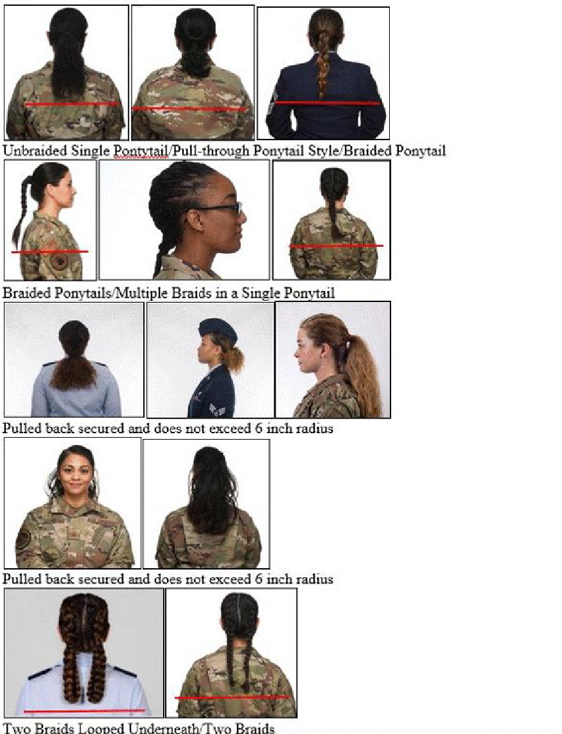

**Figure 3.3. Unauthorized female Ponytail Examples.**

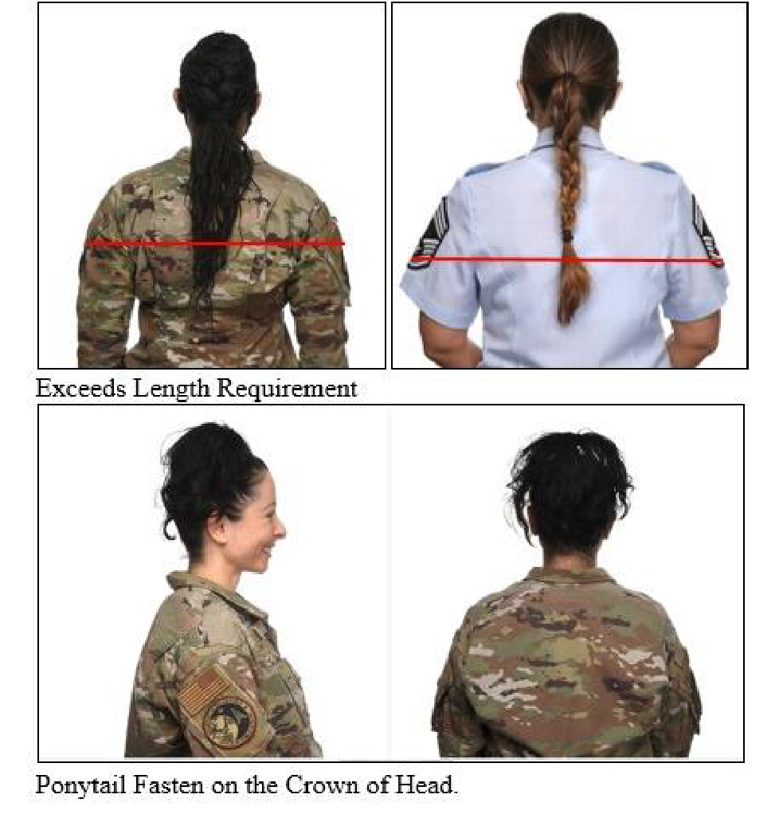

## Figure 3.4. Female Hair Style Examples

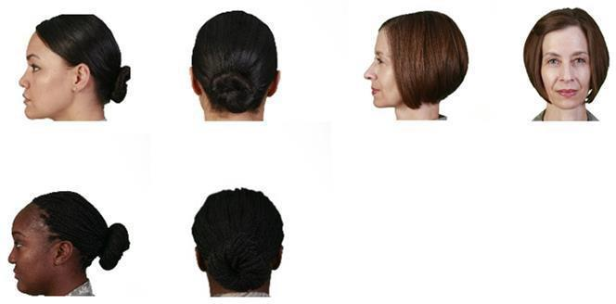

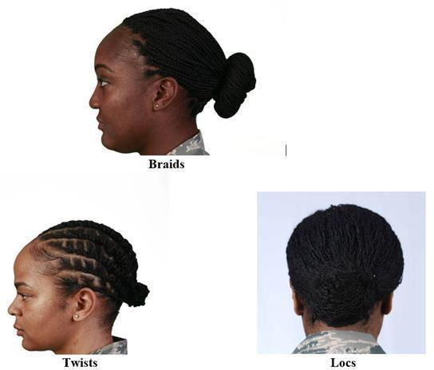

**Specific Male Cadet Grooming Guidelines. (See Figure 3.1)**

# **Hair-Male**. Tapered appearance on both sides and the back of the head, both with and without headgear. A tapered appearance is one that when viewed from any angle outlines the member's hair so that it conforms to the shape of the head, curving inward to the natural termination point without eccentric directional flow, twists or spiking. A block-cut is permitted with tapered appearance. Hair will not exceed **2 ½ inches in bulk**, regardless of length and ¼ inch at natural termination point; allowing only closely cut or shaved hair on the back of the neck to touch the collar. Hair will not protrude under the front band of headgear. Cleanly shaven heads, military high-and-tight or flattop cuts are authorized. **Prohibited examples (not all- inclusive) are Mohawk, mullet, cornrows, dreadlocks or etched shapes and/or design**. Cadets may have one (cut, clipped or shaved) front to back, straight-line part, not slanted or curved, on either side of their head, above the temple. Part will not exceed 4 inches length or ¼ inch width. Men are not authorized hair extensions. See **Figure 3.1**

**Mustaches**. Male Cadets may have mustaches; however, they will be conservative (moderate, being within reasonable limits; not excessive or extreme) and will not extend downward beyond the lip line of the upper lip or extend sideways beyond a vertical line drawn upward from both corners of the mouth.

**Beards** are not authorized unless for medical reasons, when authorized by a medical official, or as authorized pursuant to a request for a religious accommodation. Beard wear authorized for religious reasons are governed by AFJROTCI 36-2001. **When authorized for medical reasons, members will keep all facial hair trimmed not to exceed ¼ inch in length.** Individuals granted a shaving profile may shave or trim their facial hair to present a neat, clean, professional image.

# **Sideburns**. If worn, sideburns will be straight and even width (not flared), and will not extend below the bottom of the orifice of the ear opening. Sideburns will end in a clean-shaven horizontal line. See **Figure 3.1**

**Fingernails.** Male Cadets are not authorized to wear nail polish.

**Cosmetics.** Male Cadets are not authorized to wear cosmetics.

**Undergarments** (Mandatory)

# Appropriate undergarments are required to be worn with all uniform combinations. Wear undershirt and underpants with all uniforms. Wear the white V-neck or athletic style tank top undershirt when wearing opened collar service uniforms only. Undershirt will be tucked into trousers. Undershirts will not have pockets.

## Figure 3.1. Male Hair Grooming Standards.

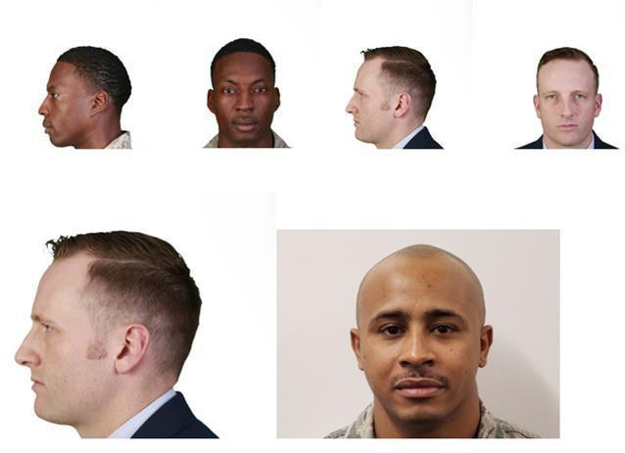

**Sideburns Mustache**

Hands in pockets are allowed while standing or walking and beverage consumption as indicated while walking.

**Cadet Uniform Wear Guidance/Policy for School Hosted JROTC Events**:

School Sponsored Military Ball with Awards Ceremony: Units have two options they may choose to utilize.

Option 1: All cadets can wear the AFJROTC Service Dress uniform.

Option 2: Each male and female cadet will be given the individual option to wear their AFJROTC Service Dress uniform or to wear formal or semi-formal civilian attire. Any civilian attire worn must be in compliance with any/all school and district policies.

NOTE: Option 2 would allow block schedule school students to attend who are not currently in AFJROTC and SFJROTC and who may not have uniforms currently issued to them.

School Sponsored Dining-Ins/Dining-Outs with Awards Ceremony: All AFJROTC cadets will wear their AFJROTC and SFJROTC Service Dress uniform.

For any other event, the SASI, in conjunction with the school Principal will decide on the appropriate attire for AFJROTC and SFJROTC cadets.

**Cadet Uniform Wear Guidance for Fundraising**:

There are no concerns with businesses contributing money to an AFJROTC booster club or other private clubs associated with AFJROTC that are NOT established by the Air Force as part of the program.

If businesses make a monetary donation, AFJROTC instructors and cadets may not advertise for the business in return – particularly in uniform. Doing so would present the “appearance” of an Air Force endorsement of the businesses making the donation. Such an appearance could be interpreted as a violation of the Joint Ethics Regulation.

AFJROTC personnel/cadets should not solicit donations from local businesses at any time.

Incorporating Corporate Sponsorship/local business donations as a way to help boost funding for your AFJROTC program is a great way to fund Leadership Development Requirements (LDR) for your cadets. The key is to contact your district and follow the above guidance to help keep sponsors and AFJROTC and SFJROTC units within the scope of the Joint Ethics Regulation.

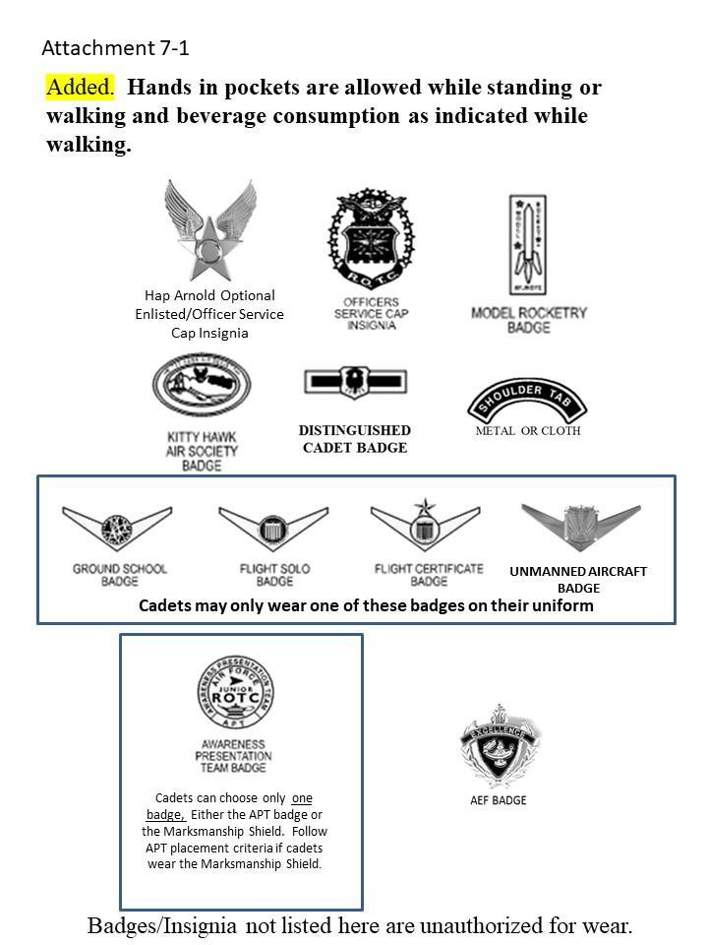

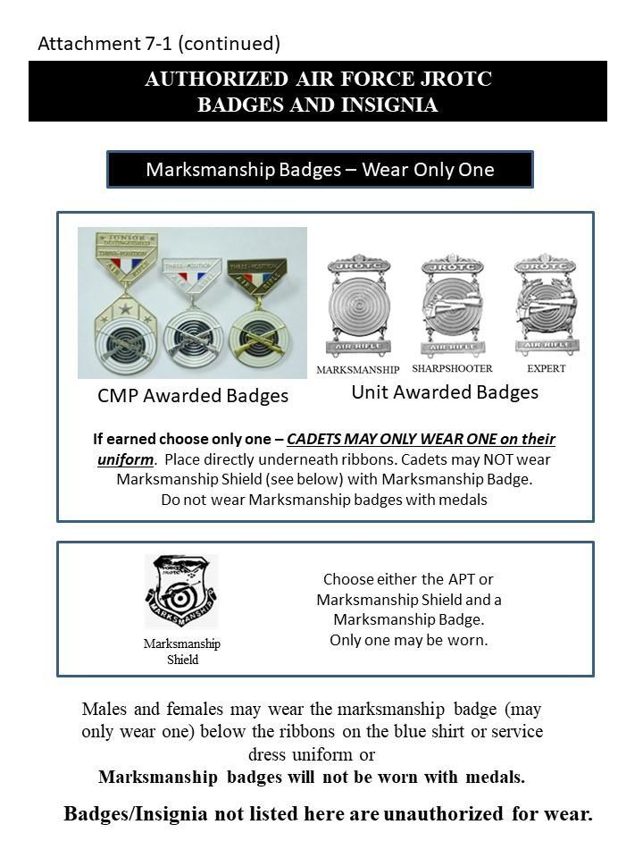

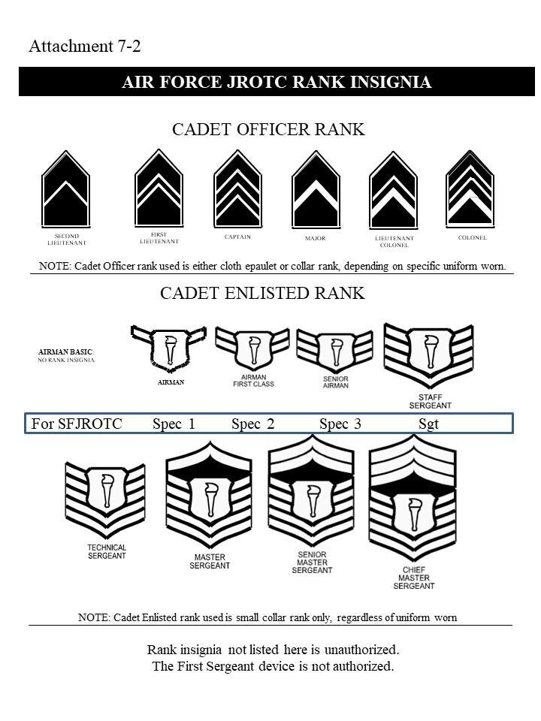

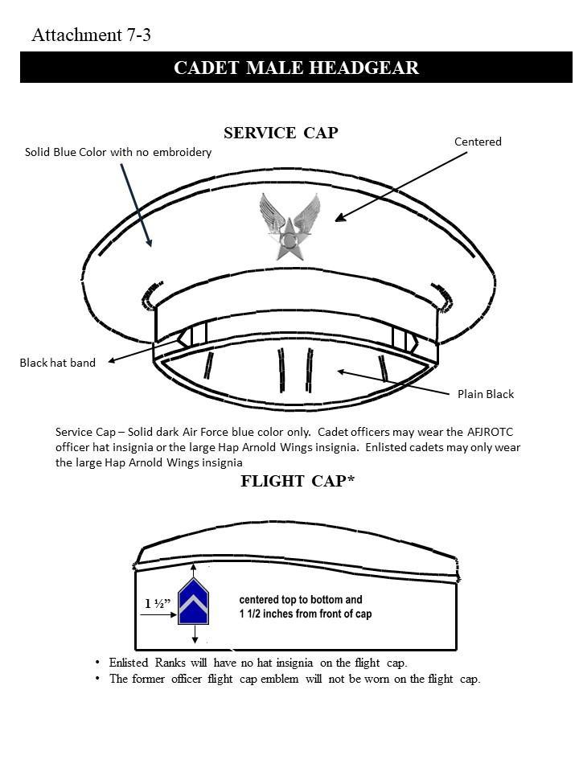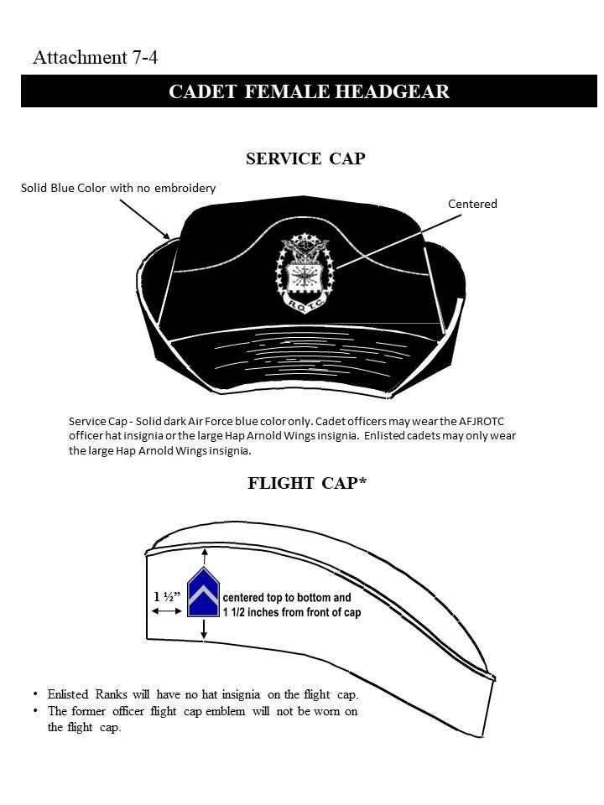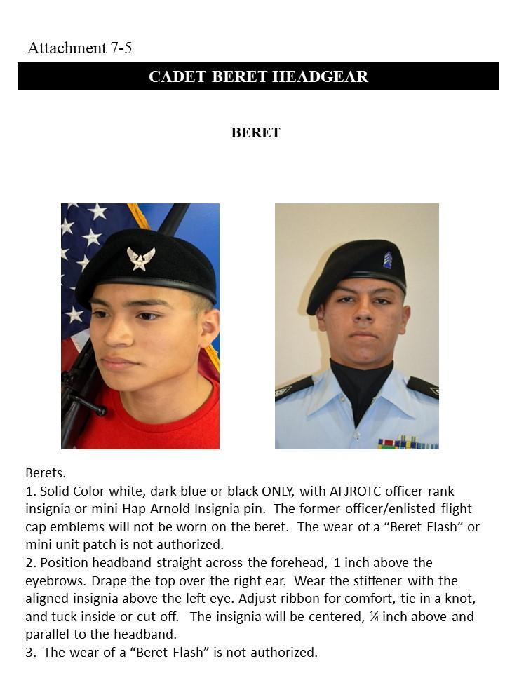

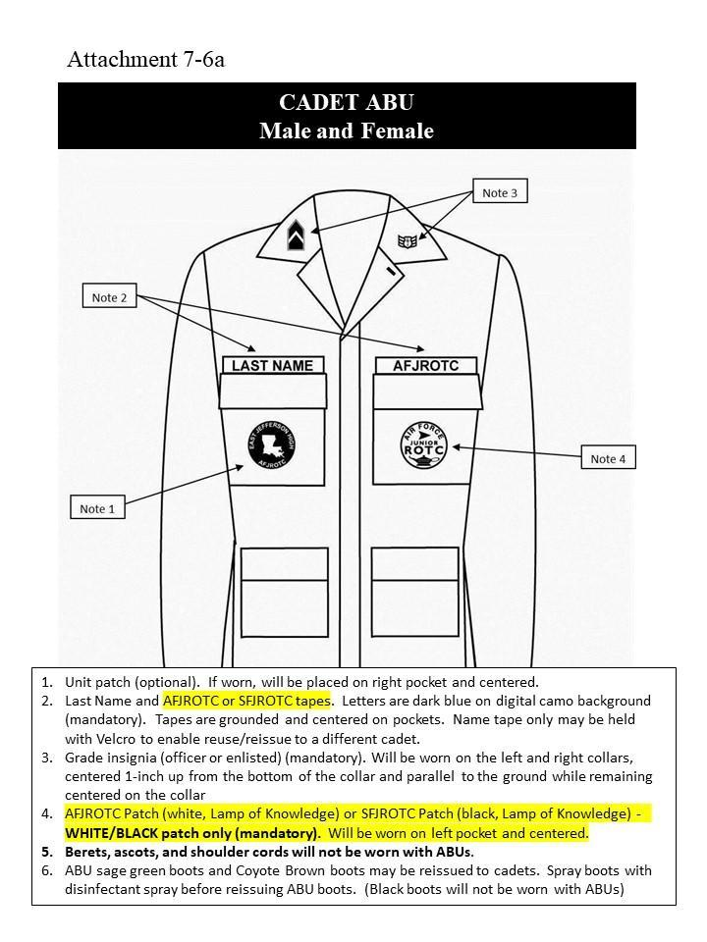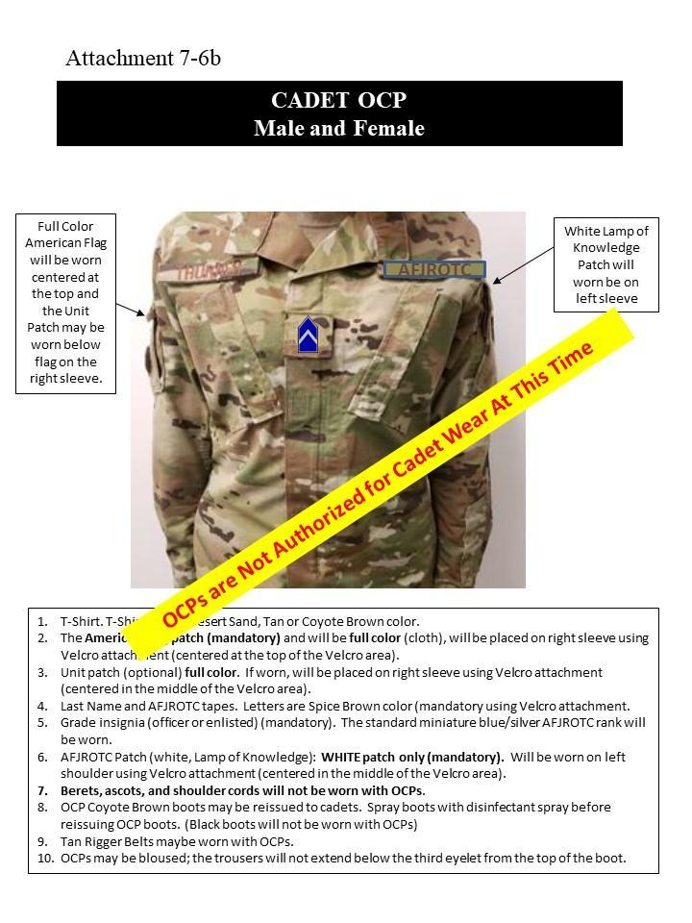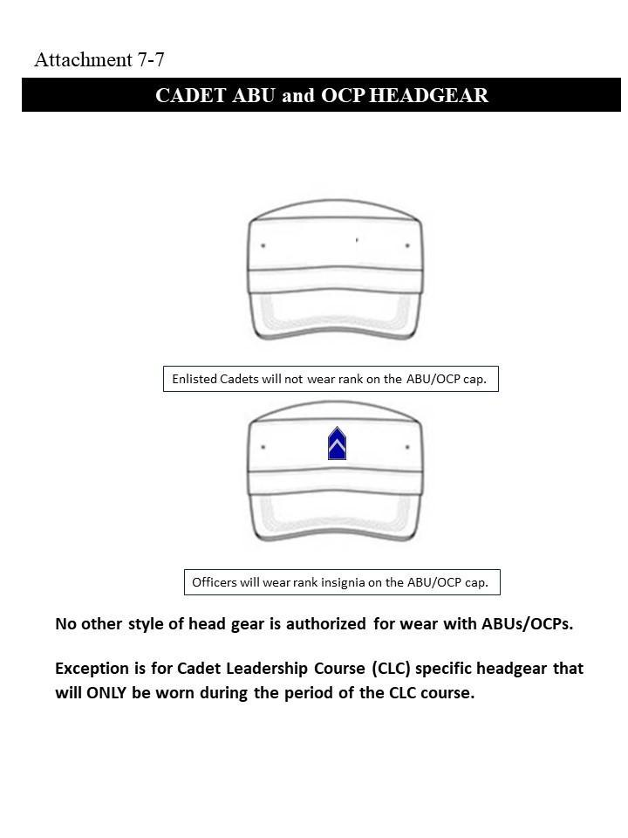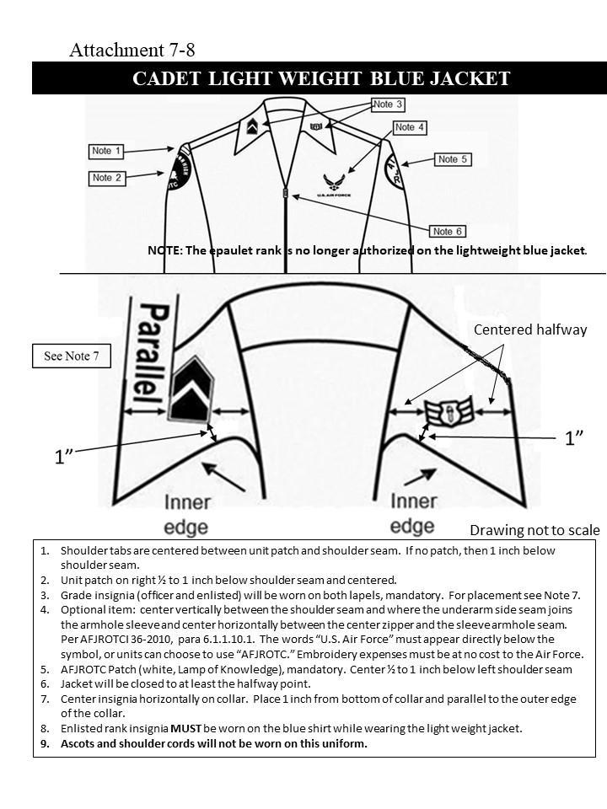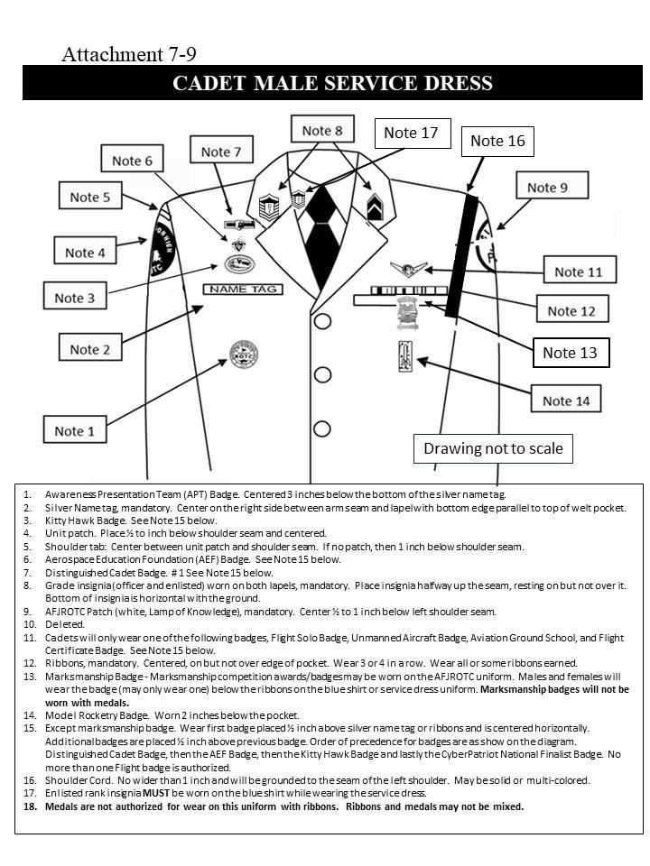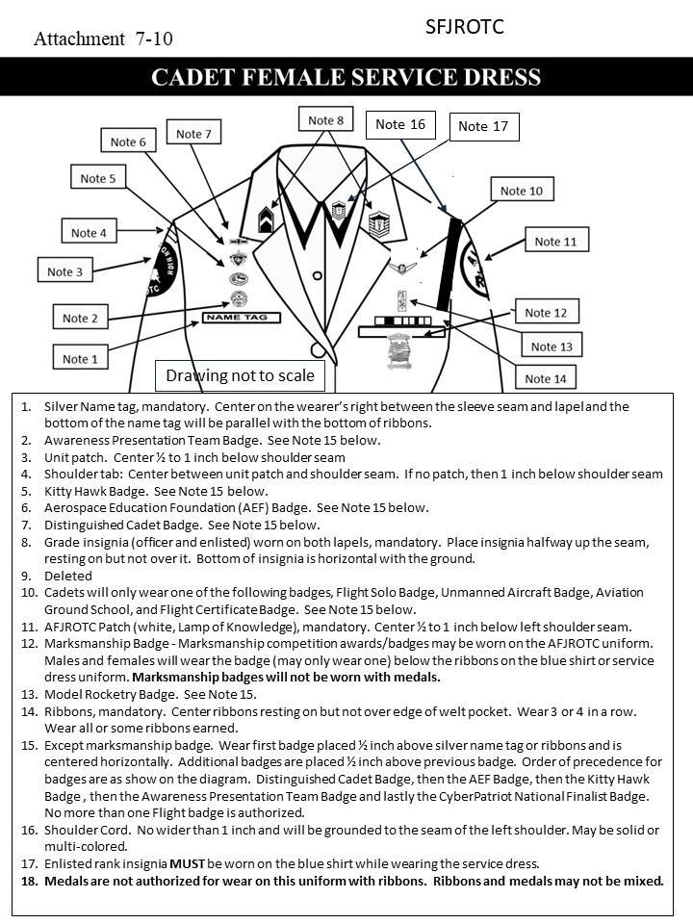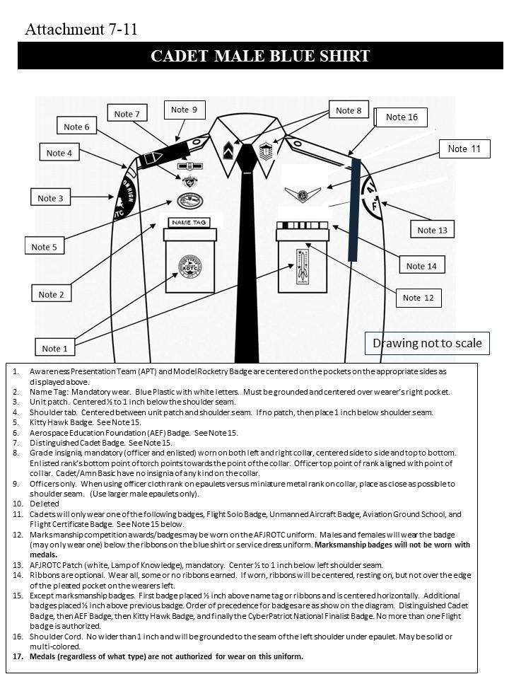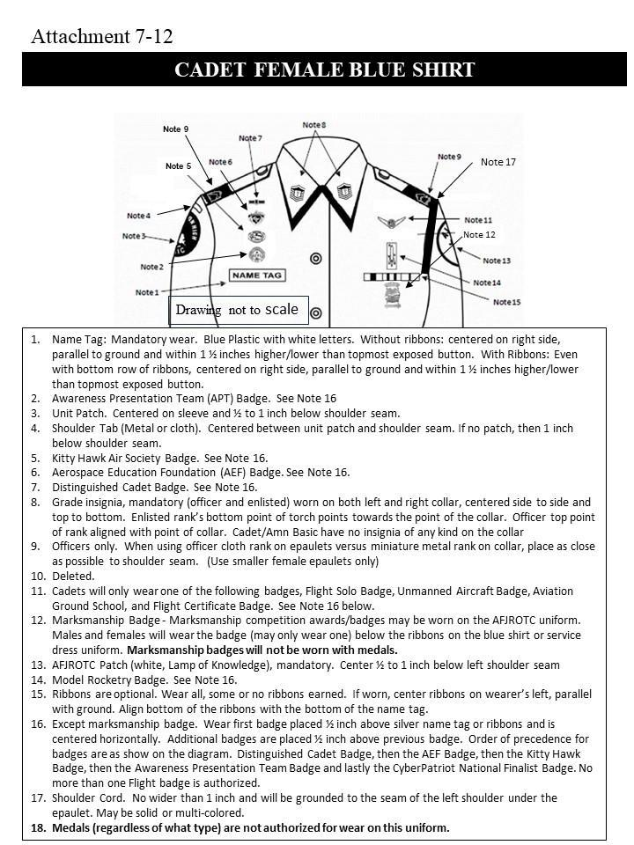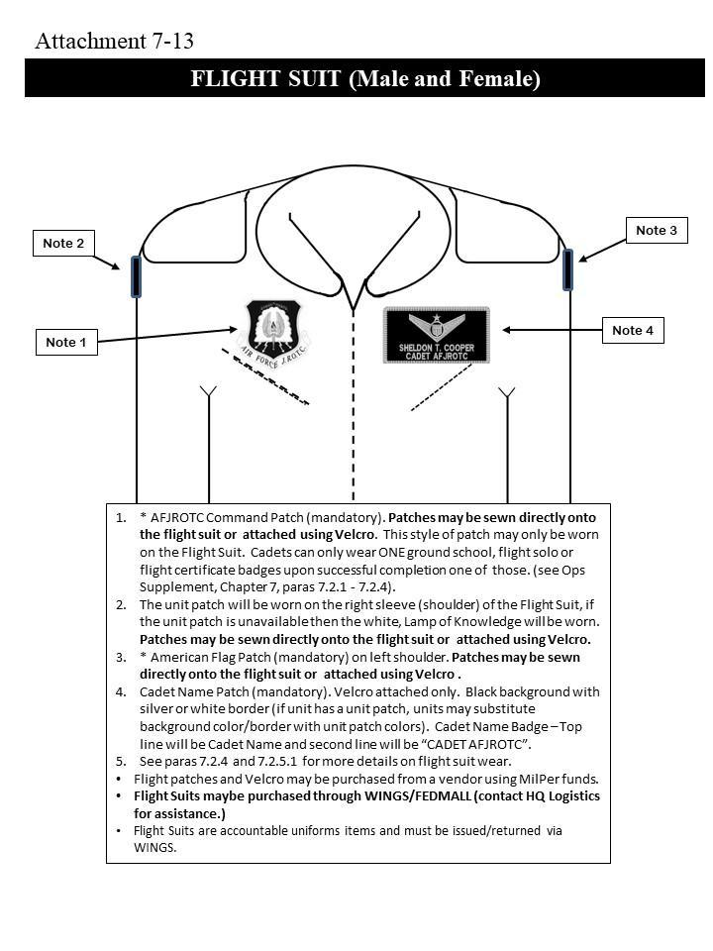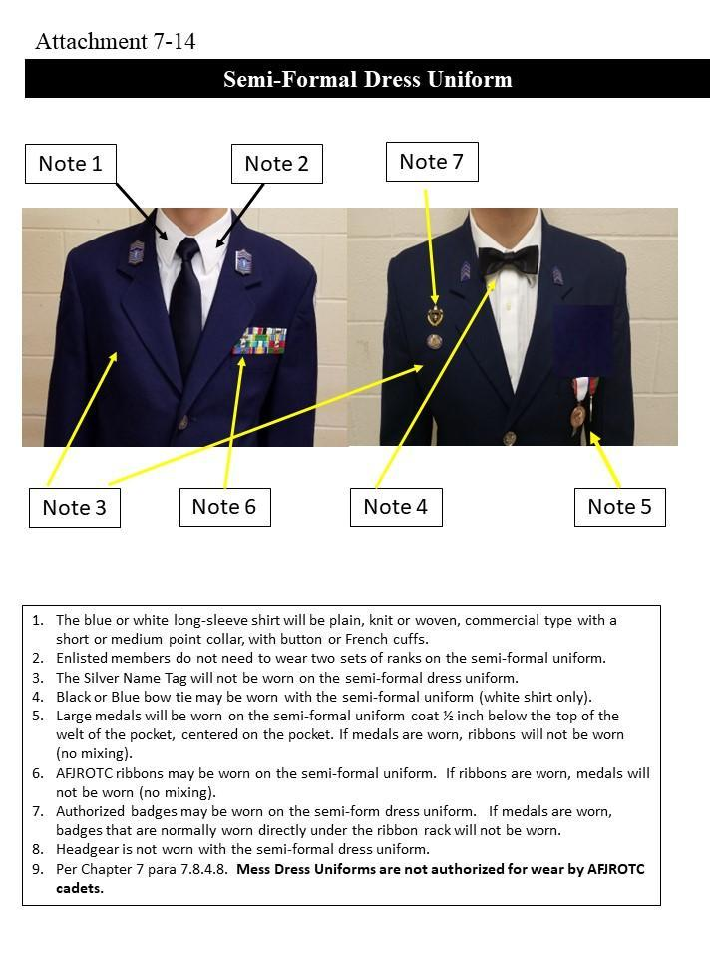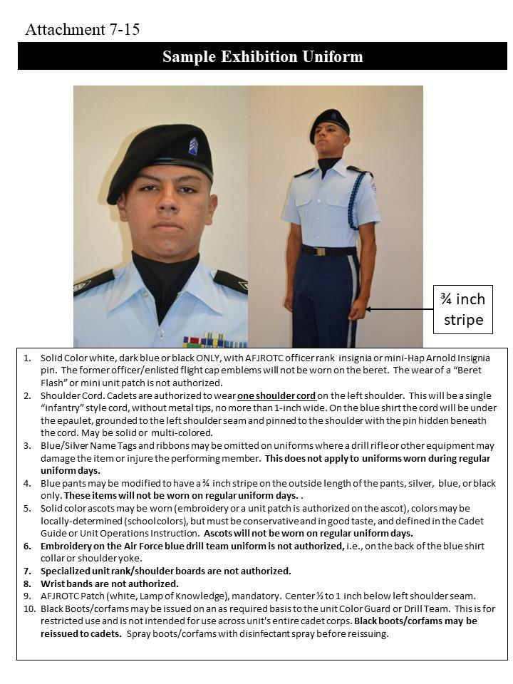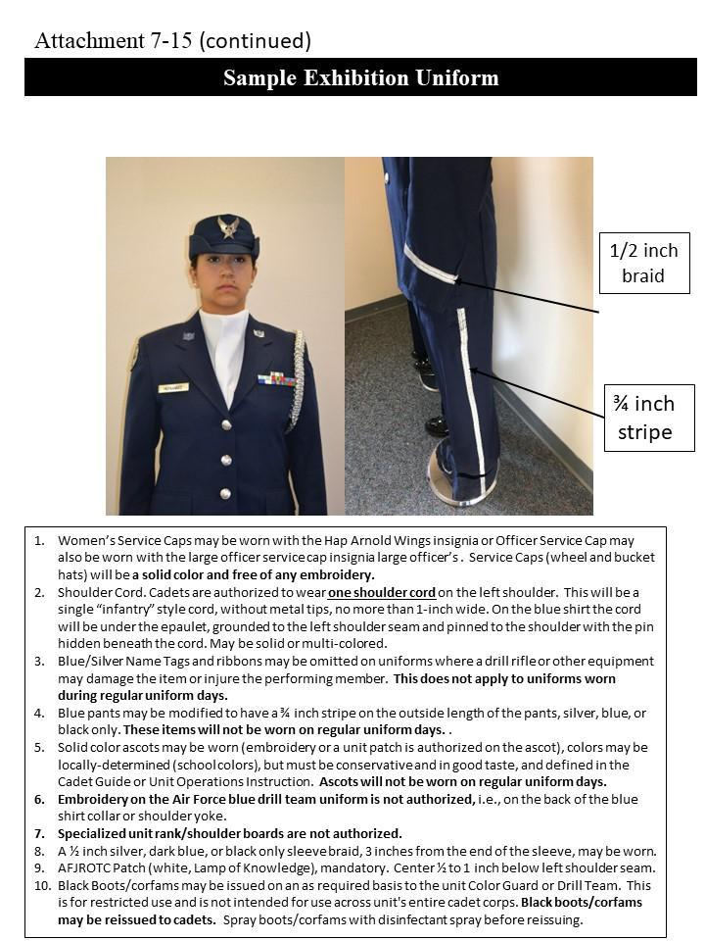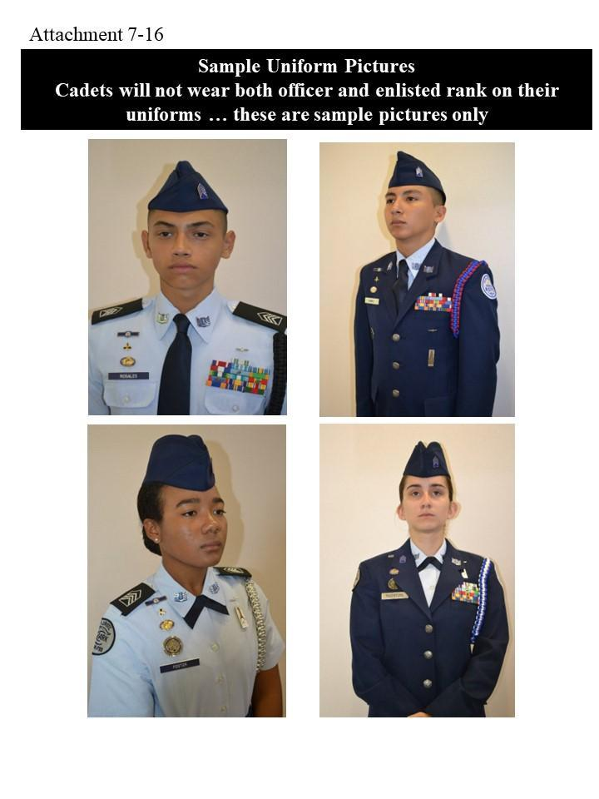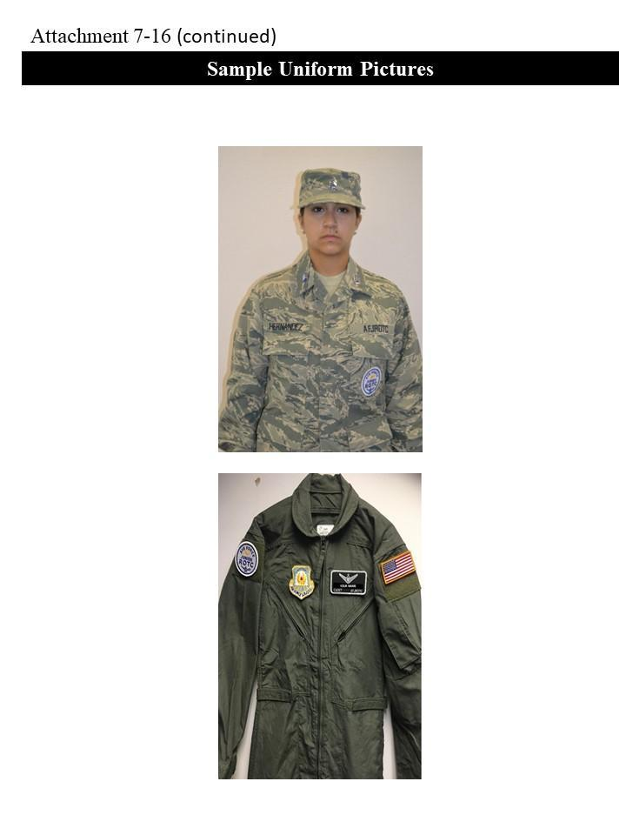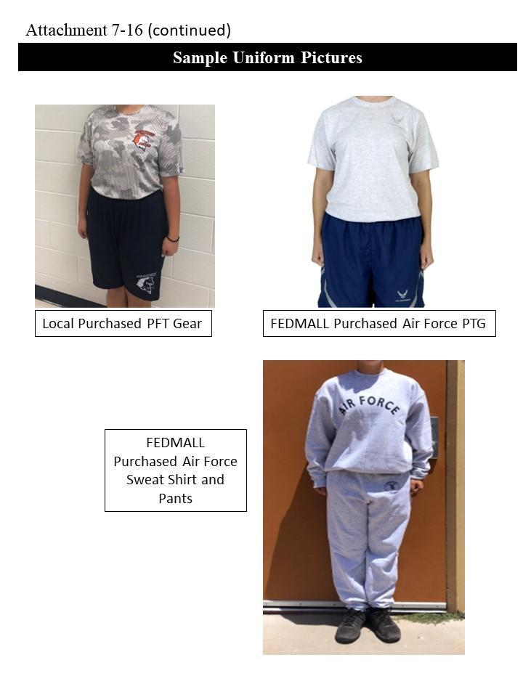

**Check Uniform:** Check your uniform on the day you take it off (not the night before you wear it) to see if it needs special cleaning or repair. If it needs cleaning, get it done RIGHT AWAY! If it needs repair or exchanging, talk to an instructor as soon as possible. We do not allow cadets to exchange items on a uniform wear day. Cadets who are learning self-discipline should not use excuses such as, **“I forgot,” “My parents didn’t wash it,” “It’s in the cleaners,”** etc. Making excuses is inconsistent with the goals of AFJROTC.

**SECTION 8 AWARDS**

**Awards and Decorations.** The AFJROTC Awards program is designed to recognize the accomplishments of cadets. Various national organizations have donated awards for the program. AFJROTC has its own awards, which are provided to cadets. For a complete list of Awards and Decorations refer to the *AFJROTC Uniform and Awards Guide*. Our annual awards program is usually held in May of each school year.

**Awards by National Organizations.**

**Air Force Association Award** is presented annually to one cadet based on academics, positive attitude, personal appearance, courtesy and growth potential.

**Daedalian Award** is presented to one cadet who has displayed high academics, outstanding leadership and patriotism.

**American Legion Scholastic Award** is presented to one cadet based on high academics, active in student activities and demonstrates leadership qualities.

**American Legion General Military Excellence Award** is presented to one cadet who ranks in the top 25% of their AFJROTC class and demonstrates outstanding qualities in military leadership, discipline, character, and citizenship.

**American Veterans Award** is presented to one qualified cadet who possesses individual characteristics contributing to leadership and displays a positive attitude toward AFJROTC programs and service in the Air Force.

**Reserve Organization Association Award** is presented to one cadet for military and academic achievement. Must be in the top 10% of their AFJROTC class.

**Military Order of World Wars Award** recognizes one cadet who excels in all military and scholastic aspects. The cadet must also demonstrate a desire to serve our nation, and have committed to continue in the AFJROTC program.

**Military Officers Association Award** is presented to a cadet who displays loyalty to the unit, school and country and shows exceptional potential for military leadership.

**Veterans of Foreign Wars Award** is presented to a cadet for high academic achievement, outstanding military bearing, leadership potential and patriotism.

**Military Order of the Purple Heart Award** is presented to a cadet who holds a leadership position in the cadet corps has a positive attitude toward AFJROTC and country and is active in school and community affairs.

**Air Force Sergeants Association Award** is presented to a cadet who is in the top 25% of his AFJROTC class and demonstrates outstanding qualities in military leadership, discipline, character, and citizenship.

**Tuskegee Airmen Inc. AFJROTC Award** is presented annually to two cadets who are in good academic standing, participate in cadet corps activities and service programs and attain a “B” or better in their ROTC class.

**AFJROTC Awards and Ribbons.**

**Valor Award (Gold).** Awards consist of a medal, ribbon, and certificate. The Gold

Valor Award recognizes the most outstanding voluntary acts of self-sacrifice and personal

bravery by a cadet involving conspicuous risk of life above and beyond the call of duty.

Forward recommendations for valor awards through debra.paggett@us.af.mil or

douglas.davenport@us.af.mil (HQ-Ops Support) for review and processing within 6 months

of the incident. Include a detailed description of the situation, newspaper clippings (if

available), statements by victims and observers, and any other information deemed

appropriate to validate eligibility. In addition, submit a proposed citation to accompany the

award. HQ-Ops Support will forward the valor award to the Director, HQ AFJROTC for

final approval. Upon approval, HQ-Ops Support will distribute the citation, medal, and

ribbon for presentation. Ribbon for this award may be worn on the cadet’s ribbon rack and

worn on regular uniform days. For each additional award earned an additional small silver

star will be awarded. Medals will not be worn on regular uniform days or during any

type of competition.

**Valor Award (Silver).** Awards consist of a medal, ribbon, and certificate. The Silver

Valor Award is awarded to a cadet for a voluntary act of heroism which does not meet the

risk-of-life requirements of the Gold Valor Award. Forward recommendations for valor

awards through debra.paggett@us.af.mil or douglas.davenport@us.af.mil (HQ-Ops Support)

for review and processing within 6 months of the incident. Include a detailed description of

the situation, newspaper clippings (if available), statements by victims and observers, and

any other information deemed appropriate to validate eligibility. In addition, submit a

proposed citation to accompany the award. HQ-Ops Support will forward the valor award

to the Director, HQ AFJROTC for final approval. Upon approval, HQ-Ops Support will

distribute the citation, medal, and ribbon for presentation. Ribbon for this award may be

worn on the cadet’s ribbon rack and worn on regular uniform days. For each additional

award earned an additional small silver star will be awarded. Medals will not be worn on

regular uniform days or during any type of competition.

**Cadet Humanitarian Award**. Award consists of a ribbon and certificate. It is

intended to recognize cadets who provide aid in response to a singular extraordinary event

such as a natural disaster or other catastrophe that has placed or has the potential to place a

hardship on their fellow citizens. This award is not to be used to recognize day-to-day

service in the community. Forward recommendations for this award through

debra.paggett@us.af.mil or douglas.davenport@us.af.mil (HQ-Ops Support) for review and

processing within 6 months of the incident. Include a detailed description of the situation,

newspaper clippings (if available), statements by victims and observers, and any other

information deemed appropriate to validate eligibility. In addition, submit a proposed

citation to accompany the award. HQ-Ops Support will forward the award to the Director,

HQ AFJROTC for final approval. Upon approval, HQ-Ops Support will distribute the

citation, medal, and ribbon for presentation. Ribbon for this award may be worn on the

cadet’s ribbon rack and worn on regular uniform days. For each additional award earned an

an additional small silver star will be awarded. Medals will not be worn on regular uniform

days or during any type of competition.

**Community Service with Excellence Award.** Award consists of a ribbon and

certificate. It is intended to recognize those individual cadets who provide significant

leadership in the planning, organizing, directing, and executing of a major unit community

service projects that greatly benefit the local community. This is not an award given to

participants but to the key leader(s) of the project. Forward recommendations for

Community Service with Excellence Award to HQ-OpsSupport@afjrotc.com for review and

approval within 6 months of completion of the project. Include a detailed description of the

contributions of the individual(s) along with newspaper clippings (if available) describing

the outcome of the project, letters of appreciation from civic leaders, or other information

deemed appropriate to validate eligibility. Ribbon must be purchased from a vendor using

MilPer funds. For each additional ribbon earned an additional bronze oak leaf cluster will

be awarded. A single silver oak leaf cluster will be used for the award of the fifth bronze

oak leaf cluster.

**Outstanding Cadet Ribbon**. Is presented to a maximum of 2% of the current unit

cadet corps population (unduplicated headcount). All currently enrolled cadets may be

considered. The award will recognize a cadet’s performance in the following key areas:

Leadership and job performance: in primary duty and specifically in preparation for the

unit’s annual assessment. Leadership qualities: involvement and positions held in

extracurricular activities. Academic performance: the nominee must be in good academic

standing in all high school coursework. Significant self-improvement, community

involvement, other accomplishments.

**Leadership Ribbon**. Is a ribbon awarded for outstanding performance in a position

of leadership as an AFJROTC cadet. Ensure recognition of cadets who have consistently

displayed outstanding leadership ability above and beyond expected performance. Criteria

for this award will be published in the unit. For each additional ribbon

earned an additional bronze oak leaf cluster will be awarded. A single silver oak leaf cluster

will be used for the award of the fifth bronze oak leaf cluster.

**Achievement Ribbon**. Is a ribbon awarded for a significant achievement in

AFJROTC or other school activities/events. Individuals may not receive more than one

ribbon during a 1-year period. For each additional ribbon earned an additional bronze oak leaf cluster will be awarded.

**Superior Performance Ribbon**. Is a ribbon awarded to no more than the top 10% of the cadet corps annually for outstanding achievement or meritorious service rendered specifically on behalf of AFJROTC. Present the ribbon for a single or sustained

performance of a superior nature. Ensure award is presented in recognition of achievements

and services which are clearly outstanding and exceptional when compared to achievements

and accomplishments of other cadets. For each additional ribbon earned an additional bronze oak leaf cluster will be

awarded.

**Outstanding Organization Award**. Is a ribbon awarded to cadets enrolled

during the academic year when a unit is selected by HQ AFJROTC to receive the OOA.

The unit will receive a congratulatory letter and a certificate of recognition which will be

posted in WINGS. OOA recipients do not receive a streamer. Ribbon must be purchased

from a vendor using MilPer funds. For each additional ribbon earned an additional small

silver star will be awarded.

**Academic Ribbon**. Is a ribbon awarded for academic excellence as signified by

attaining an overall grade point average of at least “B” for one academic term (cadet may only receive one award annually), in addition to an “A” average in AFJROTC. For each additional ribbon earned an additional bronze oak leaf cluster will be awarded. A single silver oak leaf cluster will be used for the award of the fifth bronze oak

leaf cluster.

**Outstanding Flight Ribbon**. Is a ribbon awarded each academic term to members of

the outstanding flight under criteria determined by the SASI. Criteria for this award will be

published in the unit. For each additional ribbon earned an additional bronze

oak leaf cluster will be awarded. A single silver oak leaf cluster will be used for the award

of the fifth bronze oak leaf cluster.

**Cadet Leadership Course (CLC) Ribbon**. Is a ribbon awarded for completion of an

approved leadership school program of at least 5 days in duration. For each additional CLC

completion an additional bronze star will be awarded. Silver Star will be awarded for

outstanding performance or leadership ability at a CLC instead of the Bronze Star. Limit

the Silver Star to 10% of the class.

**Special Teams Placement Ribbon.** Is a ribbon awarded to team members for placing

1st, 2nd or 3rd in an Air Force or Joint Service (national-level) Competition to include

Drill Teams, Color Guard Teams, Marksmanship Rifle Teams, Saber Teams, Academic

Bowl Teams, CyberPatriot, StellarXplorers etc. For each additional ribbon earned an

additional bronze oak leaf clusters will be awarded. A single silver oak leaf cluster will be

used for the award of the fifth bronze oak leaf cluster.

**Orienteering Ribbon**. Is a ribbon awarded to team members for completing a unit-

specific Orienteering program as part of unit curriculum. Criteria for this award will be

published in the unit. For each additional ribbon earned an additional bronze

oak leaf clusters will be awarded. A single silver oak leaf cluster will be used for the award

of the fifth bronze oak leaf cluster.

**Leadership Development Requirement (LDR) Leadership Ribbon**. Is a ribbon

awarded at the SASI’s discretion for leadership in AFJROTC Leadership Development

Requirement activities (such as but not limited to PT team commander, orienteering team

commander, drill team commander, color guard team commander, dining-in chairperson,

military ball chairperson, etc.). ’s CadetGuide. For each additional ribbon earned an additional bronze oak leaf cluster will be awarded. A single silver oak leaf cluster will be used for the award of the fifth bronze oak

leaf cluster.

**Drill Team Ribbon**. Cadets must be on the drill team for an entire year/drill season

to be eligible to qualify and must have competed in at least 3 drill performance events, i.e.,

competitions, special school events, community demonstrations (cumulative). Criteria for

this award will be published in the unit. For each additional ribbon earned an

additional bronze oak leaf clusters will be awarded. A single silver oak leaf cluster will be

used for the award of the fifth bronze oak leaf cluster.

**Color Guard Ribbon** Cadets must perform at least 10 color guard performance

events to receive this ribbon (cumulative). For each additional ribbon earned an additional bronze oak leaf cluster will be awarded. A single silver oak leaf cluster will be used for the award of the fifth

bronze oak leaf cluster.

**Flag Detail Ribbon** Cadets must perform at least 10 flag details to receive the ribbon. For each additional 10 flag details completed, another ribbon will be earned and a bronze oak leaf cluster will be awarded for the ribbon. The single silver oak leaf cluster will be awarded for the fifth bronze oak leaf cluster.

**Saber Team Ribbon**. Cadets must perform at least 3 saber team performance events

to receive this ribbon (cumulative). For each additional ribbon earned an additional bronze oak leaf cluster will be awarded. A single silver oak leaf cluster will be used for the award of the fifth bronze oak

leaf cluster.

**Service Ribbon**. Awarded for distinctive performance in school, community or ROTC service projects. Limit to members whose active participation in a service project contributes significantly to the goals of the organization. CO-20071 awards the service ribbon on an annual basis upon completion of 15 service hours

**Longevity Ribbon**. Awarded for completion of each AS year.

**Physical Fitness Ribbon**. Is a ribbon awarded for participation in the unit health

and wellness physical fitness program. All cadets who participate in the unit’s wellness

program may receive the Health and Wellness Ribbon. Subsequent yearly award of the

Health and Wellness Ribbon will be denoted by the addition of a Bronze Oak Leaf cluster to

the ribbon for each additional year of award. Cadets who score in the Physical Fitness

Test’s 75-84% will receive a Bronze Star device; 85-95% will receive a Silver Star device;

and 96-100% will receive a Gold Star device. These cadets, if already wearing the ribbon

with oak leaf cluster(s), will receive and wear an additional Health and Wellness Ribbon

with the highest-level Star Device(s) affixed. Duplicate awards of the Bronze, Silver or

Gold percentile will be denoted by the addition of another star on this ribbon. Should a

cadet subsequently score in a higher percentile, only the star representing the higher

percentile will be worn. In no case will a cadet mix different color stars, or star(s) and oak

leaf cluster(s) on the same ribbon..

**Recruiting Ribbon.** Is a ribbon awarded for outstanding effort in support of unit

recruiting activities. Sand Creek High School Cadets must have directly contributed to the recruitment of two new members to AFJROTC.

**Activities Ribbon.** Awarded for participation in co curricular activities other than Drill, Color Guard, and Saber teams. These include, but are not limited to Kitty Hawk Air Society, orienteering teams, model rocketry clubs, AFJROTC academic teams, and AFJROTC sports teams. An oak leaf cluster should be added to this ribbon for each year of membership beginning with the second year. CO-20071 cadets who spent 25 hrs during a school year on co-curricular activities as stated above will have met the criteria for this ribbon.

**Attendance Ribbon.** Awarded to cadets with no more than 3 absences for the academic year. Awarded annually.

**Good Conduct Ribbon.** Awarded to cadets with no in or out of school suspensions or any referral from their teachers. Awarded annually.

**Dress and Appearance Ribbon.** Awarded for wearing uniform on all designated uniform days and conforming to all AFJROTC dress and appearance standards as evidenced by maintaining a 90% or better uniform wear grade. Earned semesterly.

**Military Model.** Create an Airforce/Aerospace Model (Planes, Satellites, Rockets, Fighter Jets) and write a short paragraph on its history. Then present the model and paragraph to the class.

**How to Earn Awards.** All awards are on a competitive basis within the category. Most awards are based upon scholastic and leadership accomplishments. Participation in AFJROTC co-curricular activities such as drill team, color guard, and cyber team is also helpful. The best way to earn an award is to do the best you can do in all phases of AFJROTC. The awards will normally come if you are exerting 100% effort in the program. Cadets who wish to be considered for a particular award must submit a letter through their chain of command to the SASI/ASI indicating the award and their qualifications to wear it.

**Wear of Ribbons.** The authorized ribbons will be worn in order of precedence as displayed on the AFJROTC ribbon chart maintained on the cadet bulletin board. The ribbons are arranged in order of importance from wearer’s right to left, top to bottom. In other words, the most important ribbon goes on the top right. Cadets will wear the appropriate cluster on the ribbon when they qualify for a ribbon multiple times, i.e. if a cadet earns the academic ribbon for both first and second semester he would wear a cluster on his academic ribbon instead of wear two of the same ribbon. See Attachment 17.

**Wear of Medals**

Medals earned from National agencies should only be worn on the uniform during special occasions (award ceremony, military ball, dining in etc…) and when authorized by the SASI. They should not be worn when participating in color guard or drill team events. Medals should be worn only on the service coat, directly below the bottom row of ribbons. They should be worn in order of precedence. Only medals that have been earned through national agencies can be worn. Medals from P.T. competitions and drill competitions can not be worn under any circumstances.

**CO-20071 Uniform Cords**

Unit CO-20071 has several different cords that can be worn by cadets. Drill team members are authorized to wear a solid maroon cord on their left shoulder after competing in two drill competitions and maintaining a spot on the drill team. Cadets inducted into the Kitty Hawk Air Society are authorized to wear a royal blue cord on the left shoulder. The Drill Team and Color Guard Commanders wear a maroon and white cord. Flight Commander’s wear a dark blue cord on the left shoulder. The Group Commander, Deputy Commanders, Command Chief Master Sergeant, and Squadron Commanders wear a blue and white cord to signify their status.

Only one cord can be worn at a time and always on the left shoulder. For example if a cadet was wearing the Drill cord for that Uniform day only the drill cord is shown.

The cords go on the Service coat and button down shirt. On the service coat the cord is hooked in two inches from the end of the coat. The shirt cord has a loop that is put over the button then epaulet put on top to keep it from falling.

**SECTION 9** **DISCIPLINARY SYSTEM**

All cadets must comply with the standards established by the cadet corps.  Cadets are expected to display correct military conduct and courtesy at all times. The standards of the corps include, but are not limited to: Average GPA, Uniform Wear, and Community Service Hours.

Classroom rules and procedures, school rules, and military customs and courtesies are standards of conduct that must be followed.  Violations of these standards of conduct will affect your leadership and academic grade, opportunity for promotion, and job selection.

**HAZING.** Hazing of cadets is strictly prohibited. Any form of physical or mental abuse will not be tolerated and will result in immediate disciplinary action from the program and the school. Hazing is grounds for immediate disenrollment from the AFJROTC Program.  **Hazing is when you inflict physical punishment, or discipline a single cadet with extreme punishment.**

Any form of hazing, whether verbal or physical, will not be tolerated within any AFJROTC unit or activity. In addition, requiring cadets, individually or as a group, to perform any physical action as a reprimand, punishment, or for failure to perform will also not be tolerated. Cadets will not condone or encourage any type of hazing or initiation rituals. Examples of prohibited physical activities include, but are not limited to: push- ups, running laps, or any inappropriate physical contact such as shoving, pulling or grabbing. Any form of verbal abuse, teasing, public rebuke or any attempt to otherwise humiliate a cadet is prohibited. This prohibition is applicable to all AFJROTC unit activities, and includes instructors, cadets and any personnel involved with or participating in an AFJROTC unit or activity. No unit may encourage, facilitate, or otherwise condone secret societies or private clubs as part of the AFJROTC program.

**Cadet Evaluation Board**: The purpose of the Cadet Evaluation Board is to review cases of misconduct, insubordination, adverse attitude towards the JROTC Program, violation of the honor code and failure to meet the overall standards of good conduct and deportment. Flight commanders, Squadron Commanders, and the Group Commander may recommend cadets for an Evaluation Board for excessive demerits or serious incidents of cadet misconduct. Cadets exceeding 50 demerits during a semester period will meet an Evaluation Board.

The Deputy Group Commander will serve as the president of the Evaluation Board.  Other members consist of the cadet's Squadron Commander/Operations Officer, Command CMSgt or First Sergeant, Flight Commander/ Sergeant, and ASI/SASI.

The Group Command CMSgt will serve as the recorder and is responsible for submitting a typed report of the proceedings signed by the Board President. The report will include final recommendations for the Group Commander and SASI/ ASI. The report will be submitted as soon as possible but no later than five school days after the board.

The Group Commander or the SASI/ASI may have members of the board removed from the board if they are considered biased towards or against the cadet.  The Group Commander will appoint a new member in this instance.

**Disenrollment.** As mentioned earlierdisenrollment from AFJROTC will be determined by the SASI. Disenrollment will be a last resort, preceded by substantiated documentation and corrective counseling, to maintain the morale and discipline of the unit.  A cadet may be disenrolled for:

* Failure to maintain acceptable standards (including uniform wear and grooming).
* Inaptitude or indifference to training.
* Disciplinary reasons.
* Other actions deemed highly inappropriate by the AFJROTC instructors.

**SECTION 10 AFJROTC LETTER PROGRAM**

Cadetsmust have: Good academic standing, no history of disciplinary infractions, an overall “A” average in ROTC an overall “C” average in other classes, have minimum required community service hours per semester and a total of 1500 service points.

The purpose of the Sand Creek JROTC Letter Program is to recognize cadets who devote extra time and effort in the program. These types of activities contribute to the corps, school, and community. Points are awarded for:

|  |  |
| --- | --- |
| **Activity** | **Points** |
| * Color Guard/Drill Team/APT/Cyber Team/ Knowledge Bowl * Attend Practice * Participate in a performance * Perform in competition * Place in competition | 10  50  100  50 |
| Perform in AFJROTC performance | 50 |
| Participate in school community service. | 50 |
| Outstanding cadet | 100 |
| Honor Roll | 50 |
| Physical Fitness Ribbon with bronze, silver or gold device | 100 |
| Participated in a PT competition | 100 |
| Kitty Hawk Air Society | 100 |
| Starting on a Varsity Team (1 per year) | 50 |
| Make Presentation to school | 50 |
| Receive Letter/Certificate of Appreciation | 50 |
| Participate in AFJROTC Fundraiser | 50 |
| Receive recognition in AFJROTC (not already covered) | 50 |
| Attend AFJROTC function | 50 |
| Letter Points | 5 |
| Holding Leadership Position | 20 |

Cadets will complete and submit an application signed by their flight commander and squadron commander. The board will consider the cadets overall performance on the corps, school, and community.

* AFJROTC letter approval board:
  + SASI/ASI
  + Group Commander/Deputy Operations Commander
  + Squadron Commander
  + Flight Commander
  + Group Command Chief Master Sergeant

**SECTION 11 CADET HEALTH AND WELLNESS PROGRAM**

Being physically fit is a necessaryrequirement for any good leader. All cadets are required to participate in the AFJROTC Health and Wellness program which comprises 20% of the curriculum for each class. The program is designed to give you the tools necessary to improve your fitness level. Students will be tested at the beginning of each school year to establish a fitness baseline score. The test, will consist of push-ups, sit-ups, and 1-mile run. Cadets will be tested again at the end of school year. Cadets are expected to show improvement on their fitness test score. All cadets who actively participate in the Health and Wellness program will be awarded the PT ribbon at the end of the year. Cadets scoring in the top 75th percentile nationally will be recognized with a bronze device for their ribbon. Cadets scoring in the 85th percentile will receive a silver device and those cadets scoring in the top 95th percentile will receive a gold device. *See Attachment 8 for Scoring Table*

All cadets must have a health-screening questionnaire on file prior to participation in any PT activity.

Cadets will be issued appropriate PT attire for both winter and summer activities. Cadets are required to wear the AFJROTC PT attire during AFJROTC PT activities. Failure to wear the appropriate attire will result in a lower PT grade.

Cadets will participate in PT every other week on Wednesday or Thursday contingent on whether they have class on C or N-day . If you do not participate and or try to participate, your PT grade will be lowered accordingly.

The SASI/ASI must approve all PT activity and be present at each PT session.

Each flight’s PT representative will coordinate and lead their flight’s PT activities.

During each PT session the flight will complete the routine specified by the group PT leader.

**SECTION 12 COMMUNITY SERVICE**

**Importance of Community Service:** is a very important part of the Sand Creek JROTC program.  Not only does it allow us to give back to the Sand Creek community but it also enables cadets to learn many things that cannot be taught in the classroom.  Cadets can earn community service hours by participating in events organized by Sand Creek JROTC. Credit will be given for almost anything that benefits the community and where the cadet or his parents didn’t receive any compensation for the time spent. However credit will only be given if the service is done on behalf of CO-20071

**Requirements:** Each cadet has a minimum community service hour requirement of 12 hours per year. It is expected that as cadets advance in the program, they will exceed the minimum.

**Community Service Events**

* **School Wide Clean Up** - Each year cadets take the lead by cleaning the community and school.
* **Fall Festival -** Every year cadets outdoor carnival with trunk o’ treat, games, music and food trucks
* **Veterans Day Parade** - Every year the unit marches as a whole in the veterans day parade.
* **Thanksgiving Baskets:** Every year the unit donates baskets of Thanksgiving food to Sand Creek families in need.
* **Boo Bash -** Every year cadets get together with other clubs to create a halloween festival. Usually arranged towards younger audiences, meant to let kids have fun while still getting candy out of it.

**ATTACHMENT 1**

**Chain of Command**

President of the United States

Honorable Joseph R. Biden

Vice President of the United States

Honorable Kamala D. Harris

Secretary of Defense

Honorable Lloyd J. Austin

Secretary of the Air Force

Honorable Frank Kendall III.

Air Force Chief of Staff

Gen. Charles Q. Brown Jr.

Chief Master Sgt. of the Air Force

CMSAF JoAnne S. Bass

Commander, Air Education and Training Command  
Lt Gen Brian S. Robinson

Commander, Holm Center  
Brigadier General Houston R. Cantwell

Director, Air Force Junior Reserve Officer Training Corps  
Colonel Johnny R. McGonigal

Senior Aerospace Science Instructor  
Lt Col (Ret.) Ryan Pontius

Aerospace Science Instructor

Chief Master Sergeant (Ret.) Benjamin Brown

**Cadet Chain of Command**

|  |  |  |
| --- | --- | --- |
| **Position** | **1st Semester** | **2nd Semester** |
| Group Commander | C/Lt Col Eric Mejia |  |
| Deputy Group Commander | C/Lt Col Sebastian Sanders |  |
| Group Command CMSgt | C/CMSgt Kathrine Taylor |  |
| Squadron Commander | C/Maj Jaden Vo |  |
| Squadron Commander | C/Maj Joe Berglund |  |
| Academic Officer | C/1st Lt Mathias Panetti |  |
| Comm Service Officer | C/1st Lt Jonathan Shay |  |
| Communications Officer | C/1st Lt Ayden Cummings |  |
| Logistics Officer | C/1st Lt Jacob Moore |  |
| Health and Wellness Officer | C/1st Lt Ziana Mcnillian |  |
| Personnel Officer | C/1st Lt |  |
| Recruiting Officer | C/1st Lt Bella Moore |  |
| Retention Officer | C/1st Lt Bella Moore |  |
| Color Guard Commander | C/1st Lt Adrianna Arauz- Caballero |  |
| Drill Team Commander | C/1st Lt |  |



**ATTACHMENT 2**

CO-20071 Unit Manning Document (UMD)

**Position Title** **Starting Grade Promotional to**

Group Commander C/LtCol C/Col

Deputy Operations Commander C/LtCol C/Col

Command Chief Master Sergeant C/CMSgt none

Squadron Commander C/Maj C/LtCol

Drill Team Commander C/1Lt C/Capt

Color Guard Commander C/1Lt C/Capt

Kitty Hawk Commander C/1Lt C/Capt

Extra Curricular Activity NCOIC C/TSgt C/MSgt

Gp Athletics C/1Lt C/Capt

Gp Logistics C/1Lt C/Capt

Gp PT C/1Lt C/Capt

Flt CC 1st Year Cadet C/SSgt C/Tsgt

Flt CC 2nd Year Cadet C/TSgt C/Msgt

Flt CC 3rd/4th Year Cadet C/MSgt C/SMSgt

Flt Sergeant 1st Year Cadet C/SrA C/SSgt

Flt Sergeant 2nd Year Cadet C/SSgt C/TSgt

Flt Sergeant 3rd Year Cadet C/TSgt C/MSgt

Guide C/SrA none

Element Leader C/A1C none

Flt Logistics Representative C/A1C none

Flt PT Rep C/A1C none

**ATTACHMENT 3**

**Cadet Job Descriptions**

**Cadet Group Commander** is responsible for:

1. Command control of the group and ensure all cadets maintain a high esprit de corps
2. Providing the group with goals directed toward the AFJROTC mission.
3. Supervising all group activities by delegating authority to group staff while requiring necessary feedback to retain knowledge of group activities.
4. The appearance, discipline, training, and conduct of the group.
5. Planning and coordinating all group activities, facilities, and resources.
6. Ensuring all cadets have the opportunity to develop leadership skills.
7. Supervising the Deputy Commander, Command Chief, and Squadron Commanders.
8. Ensuring the Corps is run smoothly
9. Conduct staff meetings minimum twice a month
10. Communicating and coordinating with the SASI/ASIs.
11. Keeping standards of the Corps up and enforcing the standards

**Cadet Deputy Group Commander** is responsible for:

1. Oversee a large project and co-manage a minor project
2. Supervise the cadet squadron leadership
3. Serving as primary project officer for the cadet handbook and implementing instructions
4. Assisting group commander as directed
5. Coordinate cadet operations with squadron and flight commanders
6. Serving on the Cadet Evaluation Board

**Cadet Command Chief Master Sergeant** is responsible for:

1. Advising the Group Commander on cadet corps problems.
2. Serving as the liaison between cadets and the group staff.
3. Serving on the Cadet Evaluation Board
4. Ensuring all flight and first sergeants carry out their responsibilities.
5. Maintaining standards of professional appearance, discipline, efficiency, training and conduct of the enlisted corps.
6. Serving other duties as assigned by the Group Commander.
7. Manage the merit/demerit system

**Cadet Squadron Commanders** are responsible for:

1. Command and control of the squadron by effectively managing the squadron staff.
2. Providing squadrons with goals directed toward the AFJROTC mission and relaying the goals to the Flight CC’s of the squadron.
3. Supervising and guiding the flight commanders, operations officer, and as well as squadron cadets
4. Informing Deputy Commander, ASI, and SASI on the status of the squadrons.
5. Holding staff meetings with the flight commanders and the Deputy Commander. The ASI an SASI serve as advisors for all squadron staff meetings.
6. Ensuring the Squadron is not falling behind in the goals of the corps by checking grades, PT scores, attendance, community service hours; and sharing the information with the Deputy Commander and Flight CC’s.
7. Motivate cadets in many aspects of the corps

**Cadet Logistics Officer** is responsible for:

1. Assisting the ASI in the control, inventory, issue, and turn-in of all Air Force and group property
2. Assisting the ASI with equipment and uniform inventories, as required.
3. Assisting the ASI in the maintenance of supply records.
4. Ensuring all uniform items are stored properly so they are ready for issue.
5. Developing an annual fundraising plan.
6. Controlling cadet financial transactions.
7. Obtaining approval from SASI/ASI for cadet fund expenditures.
8. Serving as fund raising special project officer.
9. Maintaining cadet fund transaction records and supporting documentation.
10. Preparing fund expenditure requirements for cadet activities and obtaining funds.
11. Presenting fund reports to commander and staff at staff meetings.
12. Preparing budget projections as required throughout the school year.

**Cadet Communications Officer** is responsible for:

1. Keeping the Cadet Corps (Plus families and the community) apprised of CO-20071 activities.
2. Maintaining group history.
3. Maintaining group bulletin boards.
4. Publicizing newsworthy items in a timely manner about cadets in the corps, school, and community publications and media

**Cadet Physical Training Officer** is responsible for:

1. Training the Flight PT NCOs
2. Developing the master PT schedule for the Corps to include the mandatory

PFT Testing Dates.

1. Ensure the Corps PT Team is trained and ready to compete
2. Serve as the Cadet-In-Charge of the Sand Creek PT Event

**Cadet Community Service Officer** is responsible for:

1. Providing overall management of CO-20071 Community Service Events
2. Tracking and inputting all completed Community Service events into the WINGS database
3. Track community service hours by flight for Outstanding Flight competition as well as for the Corps goal measurement.
4. Make sure cadets go to as many events as possible

**Cadet Recruiting and Retention Officers**

* Plan events to inform incoming freshmen about JROTC
* Plan events to inform Sand Creek students not already in JROTC about opportunities in JROTC
* Gather information on why students decide to continue in JROTC or decide not to continue in JROTC
* Organize events to build esprit de corps

**Cadet Academics Officer** is responsible for:

1. Ensuring cadets meet the GPA standards of the corps and promoting academic competition among the corps.
2. Creating and running the corps’ tutoring program as well as assisting the Kitty Hawk Air Society officer in academic recognition and rewards. The Academic officer and the Kitty Hawk Air Society officer will personally tutor cadets deemed high academic risk by corps leadership, with the assistance of their respective NCOICs.
3. Assisting the Squadron Commanders establishing which cadets and which overall flights need academic attention during the course of the school year, as well as keeping academic information in the corps up to date throughout the year.
4. Helping the Kitty Hawk Air Society officer run the academic bowl team.

**Cadet Drill/ Rifle, Color Guard, Honor Guard, Saber team, Cyber team, Knowledge Bowl, Flight, and Kitty Hawk Air Society, Commanders** are responsible for:

1. Writing instructions/plans covering membership and operations policies and procedures
2. Recruiting, equipping, organizing and training team members
3. Publicizing organization activities in corps, school, and community publications and news media (with SASI/ASI prior approval)
4. Raising funds to support activities
5. Adopting local groups as community service initiatives and mentors

**All Team NCOs** are responsible for:

1. Learning from the CO on how to run the team.
2. Manage the equipment, if any, that the team has

**Cadet Flight Commander** is responsible for:

1. Commanding flight in the classroom and in formations
2. Supervising cadets and evaluating their performance, conduct, leadership, and promotion potential
3. Providing drill and ceremonies training to flight cadets
4. Calling roll and reporting attendance
5. Ensuring compliance with classroom rules and procedures
6. Enforcing cadet conduct and discipline during class and formal formations
7. Recommending improvements to flight conduct and operations to SASI/ASI
8. Inspecting flight members as directed during uniform and personal appearance inspections

**Cadet Flight Sergeant** is responsible for:

1. Assuming command of the flight in the absence of the flight commander
2. Assisting flight commander with flight conduct and discipline
3. Training element leaders and the flight guide on proper drill and ceremonies
4. Assisting flight commander in teaching drill and ceremonies
5. Preparing flight for inspection and accomplishing inspection records

**Cadet Element Leader** is responsible for:

1. Assuming duties of flight sergeant in their absence.
2. Supervising element members.
3. Training element members.

**Cadet Flight Guidon Bearer** is responsible for:

1. Accomplish duties of Guidon Bearer described in Drill and Ceremonies manual

**All Cadets** are responsible for:

1. Taking pride in and wearing the uniform correctly.
2. Taking an active role in the cadet corps by assisting/participating in corps fundraising, special projects, and other corps activities.
3. Reporting/correcting other cadets who violate cadet corps policies.
4. Always being a positive representative of the cadet corps through words and actions.
5. Always treat fellow cadets with respect, dignity and honor.
6. Looking out for and assisting other cadets when necessary.
7. Preparing themselves to assume future leadership positions.
8. Continuously striving to improve themselves and the cadet corps
9. Knowing the Chain of Command

**ATTACHMENT 4**

**SAND CREEK HIGH SCHOOL**

**AFJROTC LETTER APPLICATION**

**Name:________________________________________________________________________________**

(Last) (First) (M)

**Grade:________________________________________________________________________________**

**Flight /Position:________________________________________________________________________**

**Program Participation:__________________________________________________________________**

**Semester GPA:________________ Semester JROTC Grade______________**

**Fitness Ribbon : _____Yes_____No** **Community Service Hours**____________

**Merits:_______________________ Demerits:__________________________**

Explain in a short paragraph why you feel you have earned an AFJROTC Letter. Please mention any special awards you have earned in AFJROTC:

____________________________________________________________________________________

____________________________________________________________________________________

____________________________________________________________________________________  
  
____________________________________________________________________________________  
  
____________________________________________________________________________________

Signature:__________________________________________________ Date:___________________

Flight Commander:__________Squadron Commander__________Group Commander_______________

(Init) (Init) (Init)

AFJROTC Letter Board: Recommend/ Not Recommend Date:_____________________________

**ATTACHMENT 5**

**Phonetic Alphabet**

|  |  |
| --- | --- |
| **Letter** | **phonetic letter** |
| A | Alpha |
| B | Bravo |
| C | Charlie |
| D | Delta |
| E | Echo |
| F | Foxtrot |
| G | Golf |
| H | Hotel |
| I | India |
| J | Juliet |
| K | Kilo |
| L | Lima |
| M | Mike |
| N | November |
| O | Oscar |
| P | Papa |
| Q | Quebec |
| R | Romeo |
| S | Sierra |
| T | Tango |
| U | Uniform |
| V | Victor |
| W | Whiskey |
| X | X-ray |
| Y | Yankee |
| Z | Zulu |

**Attachment 6**

**Army SPC. Rob L. Nichols**

Army Spc. Rob L. Nichols was born in Rapid City, South Dakota in 1988 and a graduate from Sand Creek High School in 2007. He attended and graduated from WYOTech in Laramie, Wyoming.

Nichols was killed in action (KIA) on 23 July, 2013 while assigned to 3rd Battalion, 15th Infantry Regiment, 4th Infantry Brigade Combat Team, 3rd Infantry Division, Fort Stewart, Georgia and was in Afghanistan serving during Operation Enduring Freedom. He was awarded a bronze star and a Purple Heart award for his service.

**Army SPC. Dane R. Balcon**

Dane was born on 27 April 1988, at Luke AFB Arizona. Dane attended Sand Creek High School and graduated in 2007. He attended Falcon High School for AFJROTC. In 2007, he enlisted in the US Army as a Fire Support Specialist.

He attended Advanced Individual Training and Basic training with 2nd Platoon, Bravo Battery, 1st Battalion 40th Field Artillery regiment at Fort Sill. SPC Balcon received his first assignment to 3rd Squadron 8th Cavalry Regt. 1st Cavalry Division, in Fort Hood, TX. He deployed to Iraq in support of Operation Iraqi in 2007. SPC Balcon was Killed In Action (KIA) on 5 September 2009 while serving with the First Infantry Division in Iraq.

**ATTACHMENT 7**

**Necktie Knots:**

**The Windsor Knot** is a wide triangular knot that is usually worn for formal occasions, this type of knot should be worn with wide spread collar shirts.

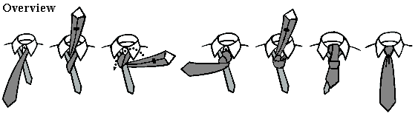

## 1. Begin with the wide end on your right and extending real low leaving the narrow end quite short.

## 2. Bring the wide end of the tie over the narrow (right side to left side)

## 3. Bring the wide end up through the middle of the loop and to the left (left side to left side)

## 4 Bring the wide end behind the narrow end (left side to right side)

## 5. Bring the wide end of the tie through the middle of the loop (right side to left side).

## 6. Bring the wide end around the front (left side to right side).

## 7. Bring the wide end of the tie through the back of the loop (right side to center).

## 8. Hold the front of the knot loose with your index finger; pass the wide end down through the loop (created in step 6)

## 9. Remove your finger and tighten the knot

## 10. Hold the narrow end and slide the knot up to the collar.

## 

## Four-in-Hand Knot

The Four-in-Hand Knot is the most popular type of necktie knot and easiest to learn, probably over 80% of tie wearers knot their ties with this. The knot is long and straight but slightly lopsided.

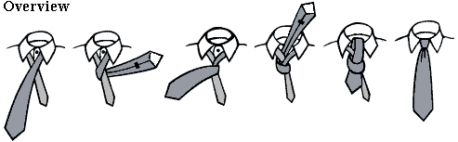

1. Begin with the wide end on your right and extending about a foot below the narrow end of your tie.

2. Bring the wide end of the tie over the narrow (right side to left side).

3. Bring the wide end underneath the narrow end (left side to right side).

4. Bring the wide end of the tie over the narrow again (right side to left side).

5. Bring the wide end of the tie through the back of the loop (left side to center).

6. Hold the front of the knot loose with your index finger; pass the wide end down through the loop (created in step 4) in front.

7. Remove your finger and tighten the knot.

8. Hold the narrow end of the tie and slide the knot up to the collar.

