1. Log into your [Parent Portal account](https://d49.powerschool.com/public/home.html) on the desktop site:

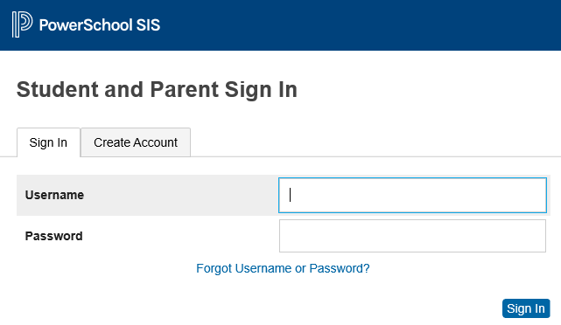

1. In the left-hand menu, scroll down and select “Fees and Transportation Services.”
   1. Please note that nutrition services uses a different fee system for meals at [payforit.net](https://www.payforit.net/)



1. This will take you to the Rycor fee system and will default to your summary page

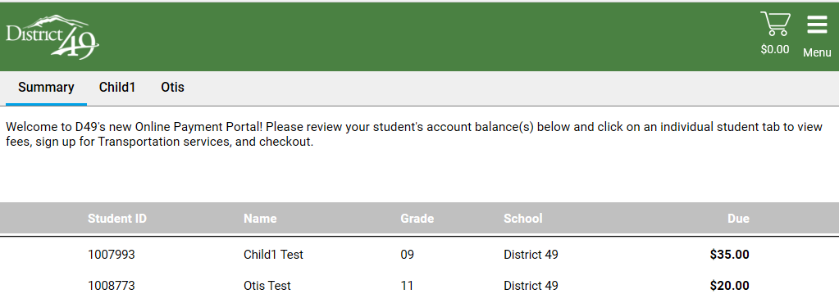

1. To see fee details or to pay a fee, click on your student’s name in the grey menu bar



1. This will take you to the detailed fee page for the selected student

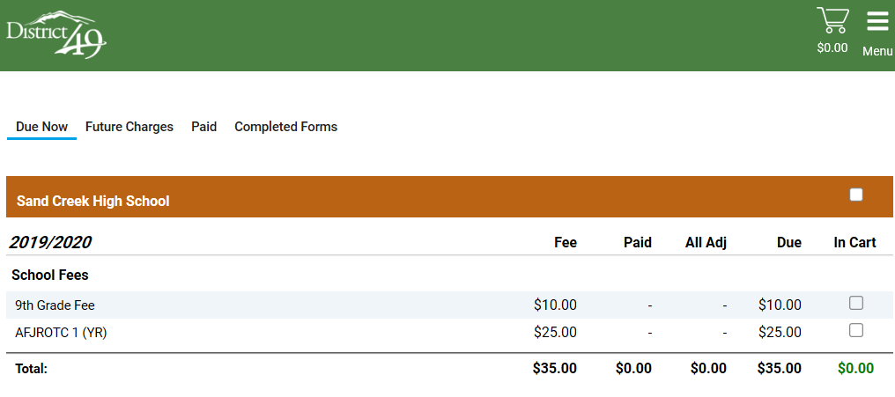

1. Some fees are optional so if you don’t see the fee you wish to pay, please reach out to your school office staff to have it assigned to your account
   1. Example: parking permit or device insurance
2. To pay a fee, click on the box(es) under “In Cart”

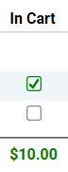

1. You will see the cart total updated based on your fee selections. Click on the cart icon in the top right corner to continue to the payment



1. This page will show you your total amount with the service fee of $2.50 including an itemized list of the fee(s) you selected to pay from the previous page.

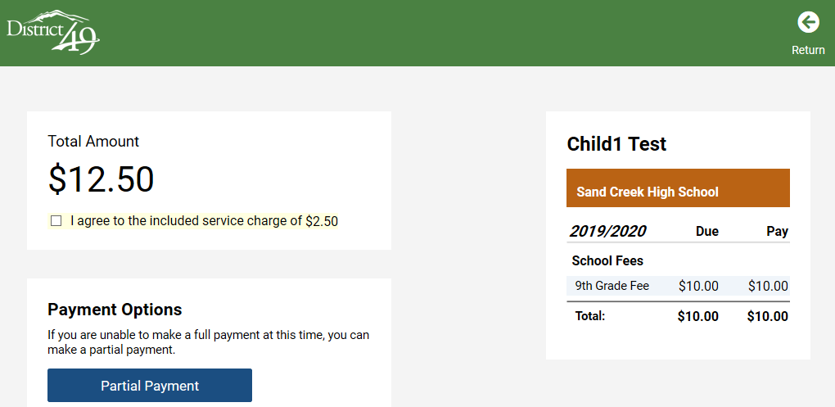

1. You can choose to make a partial payment or continue to pay in full via credit card by entering the requested info and clicking “submit payment”

