# SAC Agenda & Minutes 1/9/2024

* Meeting called to order at 3:25pm
* Introductions & Attendance
  + Cassi MacArthur
  + Gary Rivas
  + Row Padilla
  + Janna Colburn
  + Sheri Baron
  + Dimitri Johnson
  + Lindsay Alonge
  + Peter Candelaria
  + Rachel Harrell
* Safety updates
  + New entry → spring break/summer
  + Additional security cameras → on bid
  + Enclosing playground fencing-> out to bid as well
    - We could just enclose with gates, or we could extend to 6 foot all the way around-> General consensus is that we would love the 6ft
  + Armed security → 4 total, on campus multiple days/week, they are still recruiting
* **Family Engagement Survey**
  + 93 responses (~18% participation)
    - Steady with last year (95)
    - Zone participation went down but we stayed steady.
    - QR codes helped.
  + Overall increase
    - 0.05+ is a “significant” change
  + Overall score of 4.32
    - 4.3+ is in the “Maintain or Increase”

TOP 3

1. I am treated with respect at this school.” (**4.52, up from 4.40**)
2. “I believe my child’s learning is a high priority at this school.” (**4.47, up from 4.42**)
3. “I believe my child has the necessary classroom supplies and equipment for effective learning.” (**4.45, ~4.44**)

BOTTOM 3

1. “I receive positive phone calls, emails, or notes about my child from the school.” (**3.89, ~ 3.88**)*
2. “I regularly receive feedback from school staff on how well my child is learning.” (**4.04, up from 3.90!**)*
3. “I believe rules are enforced consistently at this school.” (**4.15**)

**Only 1 out of the 15 elements scored below a 4.00!!!**

* **Employee Engagement Survey  
  Zone Overall Scores**
  + Participation - **495** *(up from 371)*
  + Overall Mean Score - **3.91** *(down from 4.11)*
  + Top Box % - **32.0%** *(down from 41%)*

**Remington Overall Scores**

* Participation - **79**
* Overall Mean Score - **3.87**
* Top Box % - **32**

**TOP 3**

1. “I believe my work positively impacts those we serve.” (**4.42, down from 4.53**)
2. “I have a clear understanding of my expectations as an employee.” (**4.18, up from 4.04**)
3. “I feel a sense of pride when I tell people where I work.” (**4.10, down from 4.22**)

**BOTTOM 3**

1. “I believe organization-level information is communicated in a timely manner across the organization.” (**3.51, down from 3.60**)
2. “I feel that organization level resources are allocated to maximize effectiveness” (**3.59 ~ 3.57**)
3. I feel that resources in my immediate work area are allocated to maximize effectiveness.” (**3.67, up from 3.57)**

* **Assessment**
  + MoY Results
    - DIBELS Literacy (*see BoY to MoY Comparing Populations report)*



* + - * Increased from 57% to 69% of K-5 students “At” or “Above” Benchmark
        + End of year target = 79%
      * Decreased “Below” and “Well Below” from

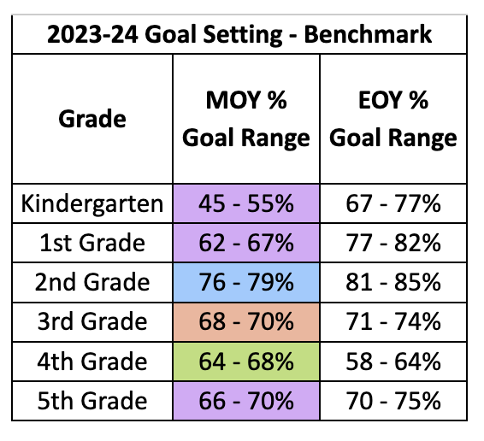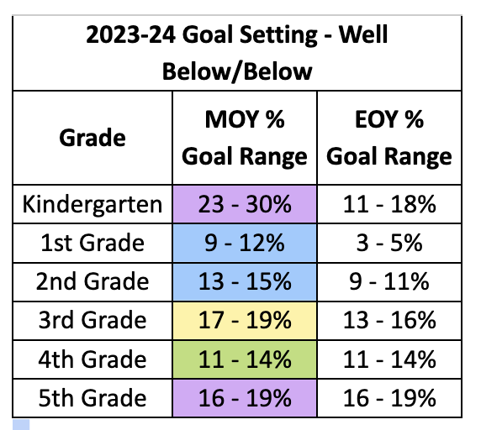

* **PBIS (positive and behavior)**

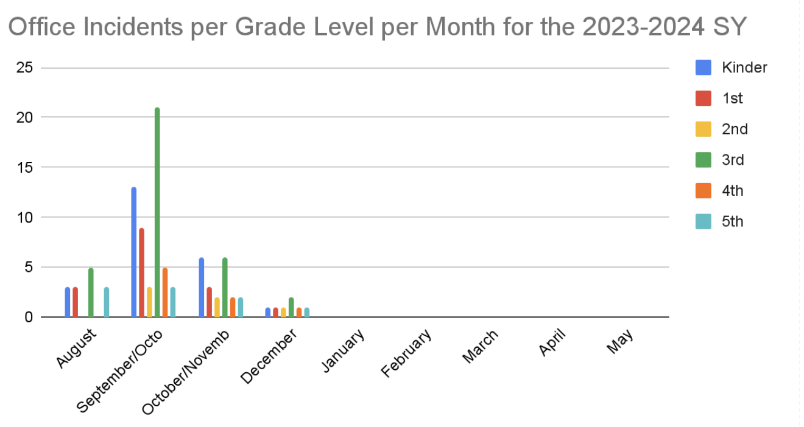

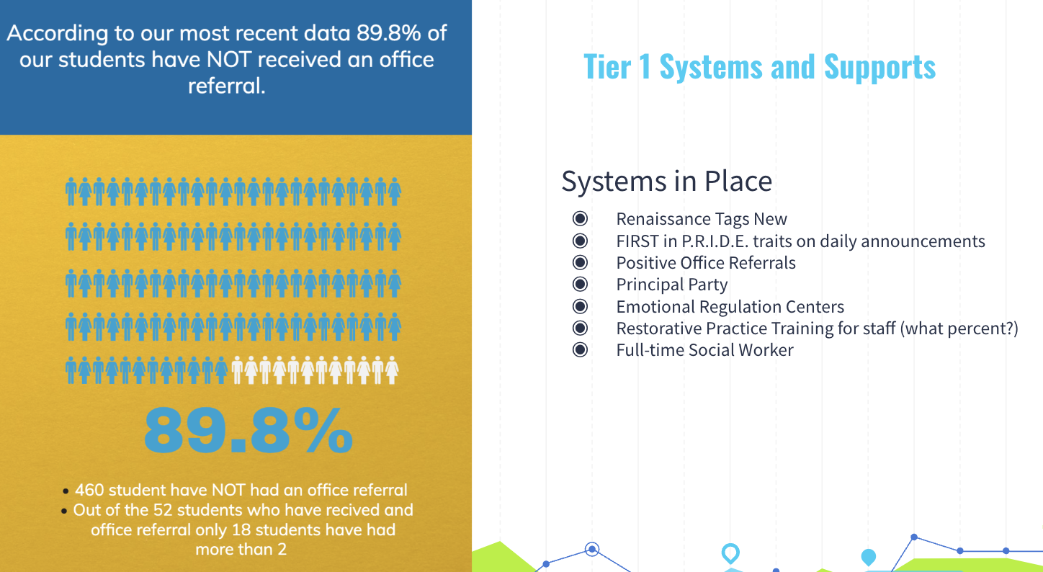

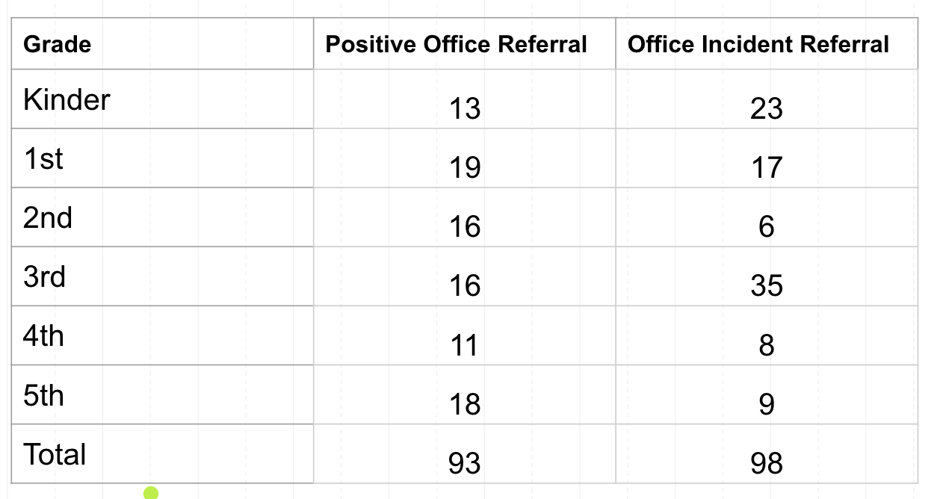

[PRIDE Tags Awarded](https://docs.google.com/spreadsheets/u/0/d/1SwRicl5hm35owzVfkBrtyM6Qxy9bLK_u1Oct0ftCVWE/edit)

| **P** | **R** | **I** | **D** | **E** |
| --- | --- | --- | --- | --- |
| **48%** | **43%** | **31%** | **23%** | **9%** |

* Open forum
  + DAAC update: No new news. Working on deficit from maintenance. Working on moving forward on multiple other projects. Additions and Transportation centers are the big projects. Safe entry for every elementary were approved.
* Next SAC Meeting
  + February 22 @ Horizon MS
    - Zone Partners @ 5:30pm
    - RES SAC @ 6:30pm
* Meeting adjourned at 4:15pm