September SAC/PTO Meeting

# Engage:

Welcome back to our familiar faces and welcome those who are new and joining us! Please share your name, student’s name and grade, and one fun activity you did this summer.

[PTO Attendance Sheet](https://docs.google.com/document/d/1hPI5yFEJIsW8i2B2rC1G27_KTzCGGLapCb1EXUf2e1U/edit?usp=sharing)

# Explore: Mission of IVES SAC/PTO

Working collaboratively together, we institute close working relationships between parents and guardians, our community, teachers, and students by evolving opportunities within the school, home, and community.

# IVES SAC/PTO Agreed Upon Norms

**How do we want to treat each other as we serve on this committee:** Open minded, with understanding, mutual respect, patience, humility, empathy, seek first to understand before being understood, listen to the quiet voices, confidentiality, presume positive intent

**What does it look like to build relationships with the school community?** Trust, function together for the greater good, transparency, common goal, open door policy, networking, information sharing, being involved, loyalty, solution oriented

# SAC:

* Pam to present UIP
* Quarterly meetings and address student achievement, school goals, and finances
* All initiatives are run through our core beliefs
* MLO [We Love D49 Teachers Presentation](https://drive.google.com/file/d/1b05DT7Is6HqcWhSSgObUTLye2CHf9Tk-/view?usp=sharing)
  + Triple 7 Plan
    - 1 thousandth of a dollar is a mill; we are asking for 7 mills
    - 7% raise for
    - 7 years
  + We need to raise the District performance framework (DPF) score by 40%
  + PZ point of contact if you would like to be involved :)

# PTO:

1. Thank you for supporting the Bouncy House! It was a hit!
   1. 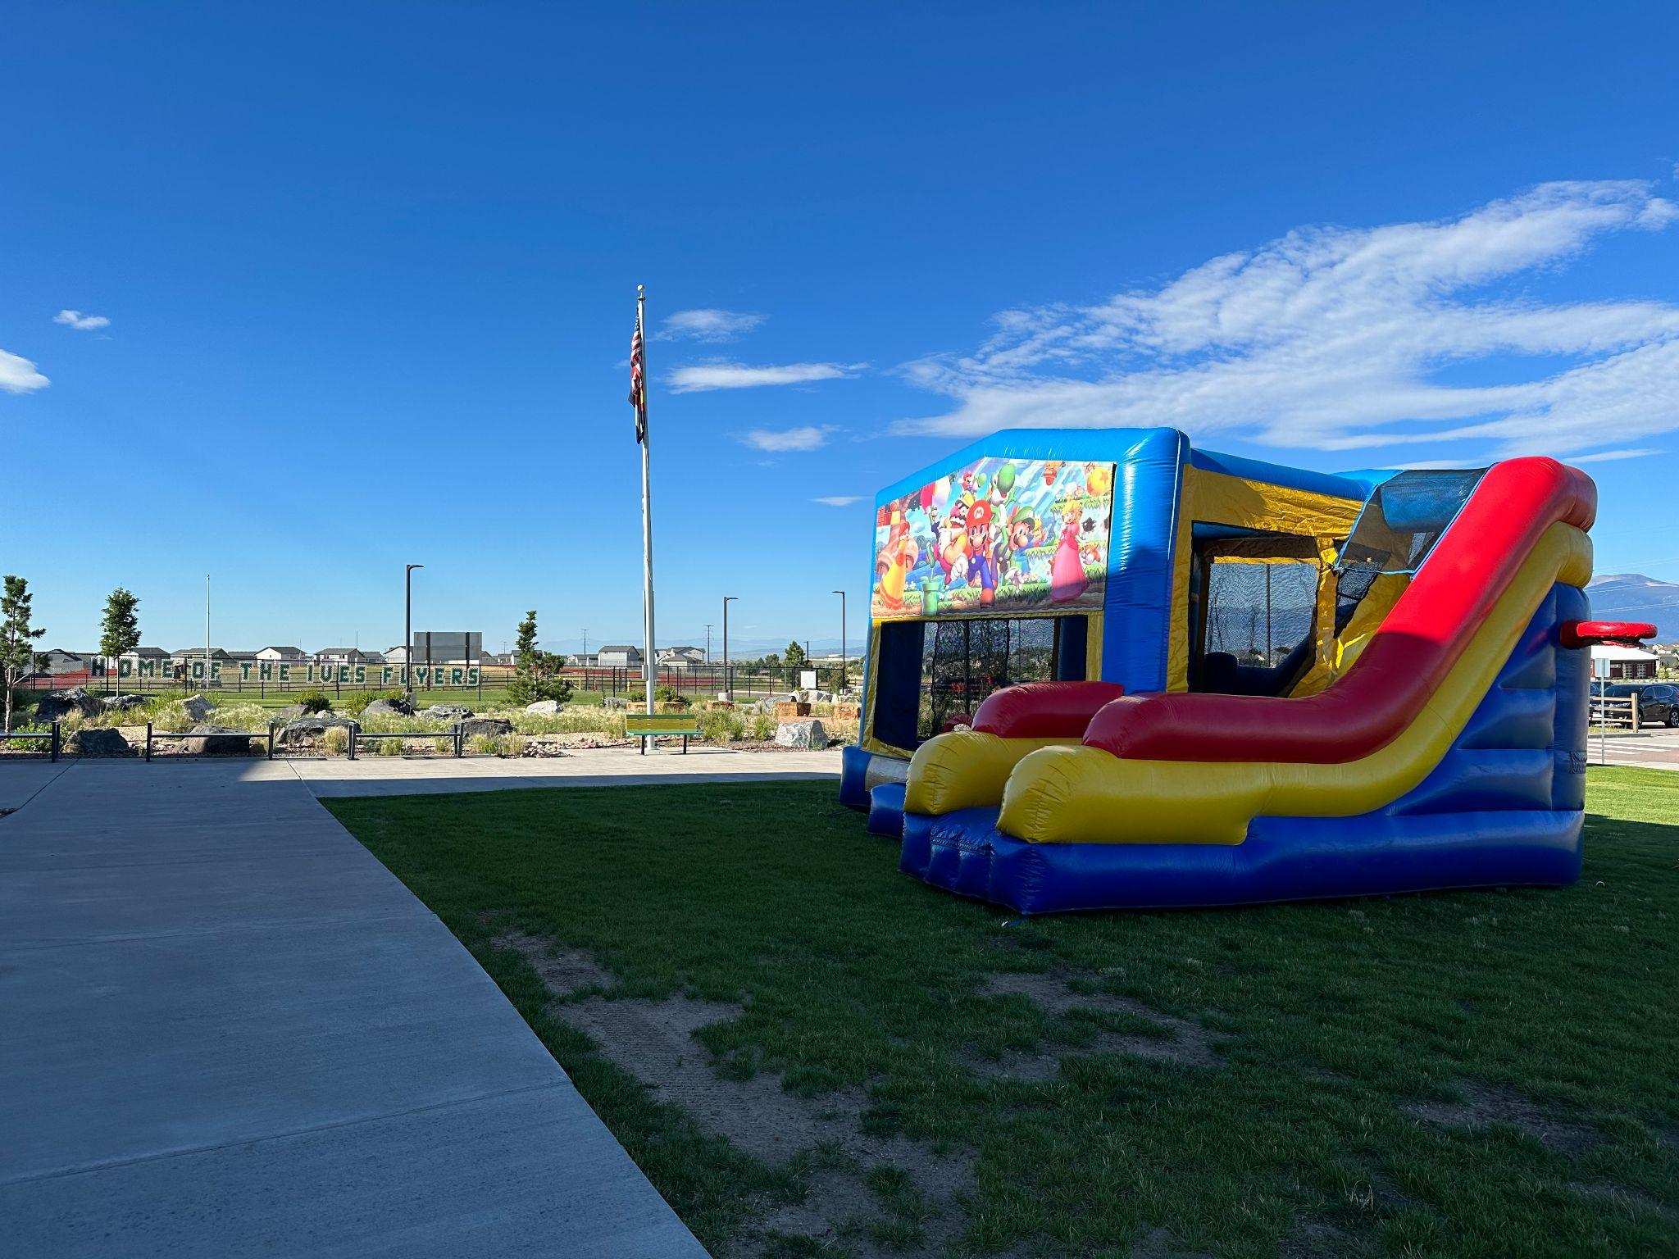
2. New: Fundraisers this year
   1. Bird Call -2 dates
   2. Dion’s-down to 1 a year due to popularity
   3. Skate City-3 dates
   4. American Furniture-year round
   5. Basket Raffle-Jan 22nd-26th
   6. School Store-Working with a new company for school swag
3. Parent teacher conference week. October 2nd-October 6th. Late night for teachers will be Thursday, October 5th. Would we support putting out a sign up genius to families for a soup, salad, dessert night?
4. Update: Girl Scouts project
5. New: Future Ideas
   1. Watch Dog Dads - costs to join, $465.00 for Elementary School Start Up Kit (required)
   2. Quick Quack Car Wash
   3. Personalized Sunglasses
   4. End of Year Celebration Party
   5. Book It Program
   6. Cole’s or See’s Chocolates
   7. Teacher Amazon wishlists - emailed out to families on spreadsheet
   8. Amazon Gives Back - sign up IVES
   9. School movie night
   10. Bingo night
   11. Craft fairs
   12. Krispy Kreme
   13. Social Media

# 

# Empower: Roles of the PT0

Building Admin: Pam Holloman, Principal; Jessica Cole, Assistant Principal

Treasurer: Megan McGuire

* Meet with building admin to discuss funds and keeps account of ledger to report out at meetings
  + Funds to date: 2, 383.08

Fundraising Coordinator:

* Oversees fundraising events
  + Working with vendor, school,and community

Communications Secretary/Community engagement:

* Lead in writing quarterly newsletter to community
* Organizes volunteers in the building for events (copies per grade level, popcorn Friday, picture day, yearbook pictures, vision and hearing, etc.)
* Supports with Parent Facebook posts

Recording Secretary: Lindsay Segner

* Takes minutes in the meetings
* Ensures signup sheet is completed and names added to the spreadsheet

Parent Representative: Christine Pretti

* Brings parent perspective

Teacher Representatives:

Brings teacher perspective as we make plans and decisions

* Brings ideas on what teachers need regarding volunteers and what type of events would encourage staff members

# Launch:

# Next Meeting date: